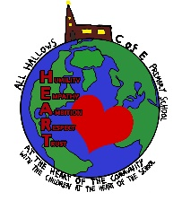
 | Autumn 1 | Autumn 2 | Spring 1 | Spring 2 |  |  |  |  | Summer 1 |  |  | Summer 2
The Literacy curriculum  Quality Text | 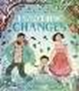 | 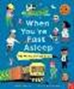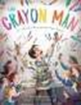 | 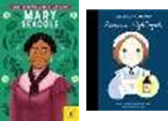  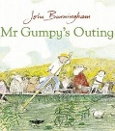  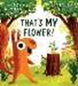 | 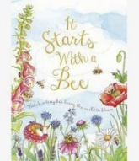  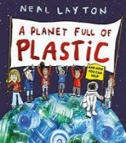 |  |  |  |  | 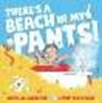 |  |  | 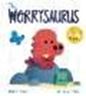
Writing Genre | Fantasy-to entertain and fuel the imagination | Historical fiction-to entertain and inform | Adventure-to entertain  Graphic Science-to engaging readers by combining adventure with education. | Explanation- conclusions, news reports, letters, |  |  |  |  | Fantasy-to entertain and fuel the imagination |  |  | Dilemma- to entertain and explore issues
Coverage | Beginning to punctuate sentences using a capital letter and a full stop,  -Leaving spaces between words | -Beginning to punctuate sentences using a capital letter and a full stop,  -Leaving spaces between words | Discuss what they have  written  Read their writing aloud clearly enough.  -Regular plural noun suffixes (-s, es)  -To combine words to make sentences, including using and-uses because to provide reasoning  -Sequencing sentences to form short narratives  -Sentence demarcation (. ! ?) | -Regular plural noun suffixes (-s,  -es)  -To combine words to make sentences, including using and  -uses because to provide reasoning  -Sequencing sentences to form short narratives  -Sentence demarcation (. ! ?) |  |  |  |  | Read their writing aloud clearly enough to be heard by their peers and teacher  -Un- prefix to change meaning of adjectives/adverbs  -Sentence demarcation (. ! ?) |  |  | Read their writing aloud clearly enough to be heard by their peers and teacher  -Un- prefix to change meaning of adjectives/adverbs  -Sentence demarcation (. ! ?)
Enrichment | Visitors into school | Visit to White Post Farm |  | Walk around Gedling |  |  |  |  | Visit to Field Farm
Community links | Going into the community | Sharing toy memories with grandparents. | Creating art work for the community. | Going into the community. |  |  |  |  | Going into the community. |  |  | Going into the community.
School values | Respect | HEART | Empathy | Humility |  |  |  |  | Trust |  |  | Ambition
British Values | Rule of the Law | Mutual Respect | Individual Liberty | Mutual Respect |  |  |  |  | Tolerance |  |  | Democracy
Personal Development | Families  Responsibilities | Caring  Friendships | Respectful relationships  Personal safety | Safety in and around the home |  |  |  |  | Democracy  Community  First Aid |  |  | Changing and Growing (SRE)  Economic  Wellbeing
Personal Development | Ongoing; Mental health, ZUMOS, Current affairs, Sun Safety
History  Key Question and Theme | Which toy would you choose?  Changes within living memory  History Theme: Home Life |  | Who was the lady with the lamp?  The lives of significant individuals in the past who have contributed to national and international achievements- Florence Nightingale and Mary Seacole. |  |  |  | Why have people gone on holiday to the Seaside?  Local History History: Settlement
History | - I know about changes in living memory (last 100 years)  - I know how chronology reveals aspects of change in national life.  - I know how to ask questions about simple artefacts.  - I know that memories are not always completely reliable  - I know the months of the year I know the month and year of my birth  - I know and use historical vocab to show the passing of time  Vocab: past, present, chronology, artefacts, week, month, year, earlier, later  - Describe how teddies have changed over a period of time  - Sequence different toys on a timeline  - Identify similarities and differences between toys from the past and now  - Explain which toy from the past they would choose to play with and why  Historical Skills  - Sequence events or objects in chronological order  - Organise artefacts by age  - Begin to identify different ways to represent the past (e.g photos, stories, adults talking about the past)  - Ask questions related to objects and historical sources  - Finds answers to simple questions about the past using information sources. |  | - I know how to ask questions about simple  artefacts (e.g. who, what, why, when, where)  - I know about a significant person from the  past and where this sits in a chronological  framework  - I know how the significant person  contributed to national and international  achievements  - I know and use historical vocab to show the  passing of time  Vocab: significant, Crimea War, lantern, soldier, charity explore who Florence Nightingale was and why she is remembered.  - Consider the differences between nursing in the past and now.  - Think about how people’s jobs and roles have changed over time.  Historical Skills  - Sequence events in chronological order using a simple timeline of Florence’s life.  - Organise historical sources (photos, drawings, artefacts, diary extracts) to show past vs present.  - Begin to identify different ways to represent the past  - Ask questions about objects and sources  Find answers to simple questions using books, pictures, and short videos. |  |  |  | Historical Skills  - Sequence key events on a simple timeline.  - Use historical sources to find out about the seaside  - Identify different ways the past can be represented  - Ask and answer questions about how seaside holidays have changed  - I know about the changes in living memory (last 100 years)  - I know how chronology reveals aspects of change in national life  - I know that memories are not always completely reliable  - I know how to distinguish between fact and fiction  - I know and use historical vocab to show the passing of time  Vocab: fact,
History Enrichment | Visit Sudbury Hall Childhood Museum  Handling Toys artefacts box  New and old toys  Letters from grandparents |  | Florence Nightingale resource box / artefacts from Nottingham Museums  Online / digital exhibitions: “Florence Nightingale Comes Home”  Workshop / talk with a nurse / local health visitor
History Texts | 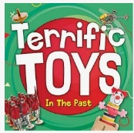   |  | 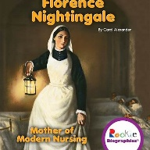  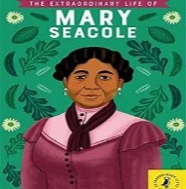  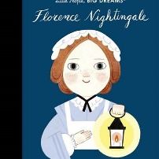 |  |  |  | 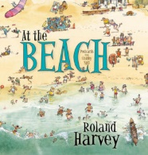
Geography  Key Question and Theme | What makes All Hallows unique?  Geography-Locational and place knowledge.  Key Concepts: Place, Space, Scale. |  | What makes Gedling unique?  Geography- Field skills and Place knowledge  Key Concepts: Place, space, scale, cultural understanding and diversity, physical and human processes. |  |  |  | How is Gedling different to Skegness?  Geography- Local Area – London city or Village Key Concepts: Place, space, scale, physical and human processes, cultural understanding and diversity.
Geography  Key Question and Theme | • There are changes in weather in each season.  • In the UK the weather can change quickly during theday.  • To use simple fieldwork and observational skills to study the geography of my school and its grounds relating to  physical and human features.  • To read and create a simple map of our school grounds.  • To use aerial photographs and plan perspectives to  recognise landmarks |  | - Identify which is the hottest and coldest season in the UK.  - Recognise key human and physical features of my local environment.  - Make simple observations on a walk of our local area. |  |  |  | - Locate the 4 countries of the UK on a map, atlas and / or globe and locate the four capital cities.  - Use aerial photographs and plan perspectives to recognise landmarks in the UK.  - Know the human and physical features of a place in England and compare to our local area. Locate the three main seas that surround the UK.  - Know own address and postcode.
Geography  Key Question and Theme | - Know that our town is called Eastwood and our nearest city is Nottingham.  - Know their address and postcode.  - Identify features and landmarks in Eastwood.  Geography Skills  - Devise a simple map and label it.  - Use aerial photographs and plan perspectives to recognise landmarks.  - use simple fieldwork and observational skills to study the geography of their school and its grounds  Vocab  Seasons  Observations  Record  Temperature  Thermometer  Affects  Landmark |  | Geography Skills  - Devise a simple map and label it.  - Use aerial photographs and plan perspectives to recognise landmarks.  - Name Gedling as a town and locate this in an atlas/on a map.  - Use simple fieldwork and observational skills to study the geography of their school and its grounds  Retrieval from F2  -Know the name of the town our school is in is Eastwood.  -That a globe is a model of the Earth and that maps show countries of the world.  Vocab  Fieldwork  Map  Route  Physical feature  Human feature  Globe |  |  |  |  | Geography Skills  - Know the points N, E, S and W on a compass and be able to use and follow simple compass directions.  - Use aerial photographs and plan perspectives to recognise landmarks.  - Use world maps, atlases and globes to identify the United Kingdom and its countries and its surrounding seas.  - Name Gedling, Nottingham and London and locate these in an atlas/on a map  - Devise a simple map and label it.  - Begin to know the difference between basic human and physical features on a map and in their surrounding environment/school grounds. Use simple fieldwork and observational skills to study the geography of their school and its grounds and the key human and physical features of its surrounding environment.  Vocab  United Kingdom  Capital City Address Country  Island Pier Promenade Resort  Tourist Ariel photographs
Geography Fieldwork and Geography enrichment. | Where on our school grounds would be a good place to launch the moon back into space?  - Surveying the school grounds for a suitable place to launch the moon back into space. Linked to class text. |  | Where has Mr Grumpy gone?  - Plotting routes on maps to find the Mr Grumpy and his belongings in our school grounds.  - External speaker – James Ketchell who has trekked across Greenland. |  |  |  |  | What human and physical features can we find on our school grounds?  - Devise a simple map and label it with human and physical features of the school grounds. Know the points N, E, S and W on a compass and be able to use and follow simple compass directions.  - Use simple fieldwork and observational skills to study the geography of their school and its grounds and the key human and physical features of its surrounding environment.
Science | Animals including Humans  - Know the name of parts of the human body that can be seen  - Measures (within Year 1 mathematical limits) to help find out more about the investigations undertaken.  - Know how to classify a range of animals by amphibian, reptile, mammal, fish and birds  - Know and classify animals by what they eat (carnivore, herbivore and omnivore)  - Know how to sort by living and non-living things. | Seasons  - Name the seasons and know about the type of weather in each season  - Name the seasons and know about the type of weather in each season  - Know which the hottest and coldest season in the UK is.  - Know and recognise main weather symbols | Materials  - Know the name of the materials an object is made from  - Know about the properties of everyday materials  - Materials -Set up a test to see which materials are absorbent know if the test has been successful and can say what has been learned  - Explain to someone what has been learned from an investigation they have been involved with and draw conclusions. |  |  |  |  | Plants  - Identify and name a variety of common, wild and green plants, including deciduous and evergreen trees;  - Identify and describe the basic structure of a variety of common flowering plants, including trees.  - Know the names of a variety of common trees  - Know the difference between deciduous and evergreen trees  - Know the names of a variety of common wild and garden plants  - Know which plants grow in the local environment
Famous Scientists/ Occupations | David Attenbourough.  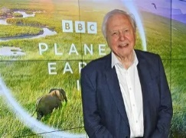 |  | Mary Seacole- Nurse  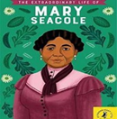 |  |  |  |  | Monty Don-Gardener  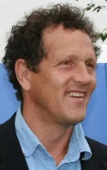
Art and Design | Buildings  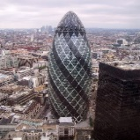  Architectural drawing of houses & local buildings from direct observation and secondary sources.  Artist: Stephen Wiltshire,  Architect - Norman Foster, Sarah Wigglesworth  - Explore a range of drawing tools e.g. sketching pencils, pencil crayons and pastels.  - Know that different sketching pencils make different marks.  - Know how to use 2 different gradient of pencils.  - 2B and 8B Pencils Chalk Pastels Pencil/s Crayon/s Draw lines of different size and thickness and explore shapes.  - Begin to make observational drawings.  - Colour (own work) neatly following the lines.  Pencil crayon motions, thickness, moods, oil pastels, blend,  wavy, straight lines, oval, centre, pressure.Thick/ness Thin Line Grade |  | Circles  Colour mixing primary and secondary colours  Colour in moods and repeated patters.  Artist – Kadinsky/ Paul Klee  Powder paint  - Use thick and thin paint brushes.  - Know the names of the primary and secondary colours.  - Mix primary colours to create secondary colours.  - Water colour / powder paint  - Discuss and use warm and cold colours.  Painting primary secondary thick thin brush/es colour  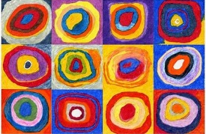    Using IT to create a picture.  Artists-Pablo Laboto  Begin to explore digital media to create an image.  Explore digital tools e.g. brushes, shape, fill tools and erase. |  |  |  |  | Cut, roll and coil materials.  Michelle Reader /Gryson Perry  - Enjoy handling, feeling and manipulating a range of materials. (wire, paper and straws.)  - Cut shapes using scissors in a safe way.  - Build a construction using straws and paper.  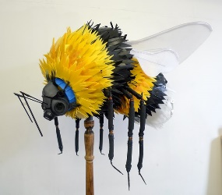
Art and Design | Artist – Describe the work of notable artists. Describe what can be seen and give an opinion. Use some of the ideas of artists studied to create pieces.
DT | Mechanisms-Moving Pictures- sliders and levers |  | Mechanisms – Cars- wheels |  | Cooking and nutrition – Holiday Picnic
RE  Nottinghamshire Agreed Syllabus | 1.1  Celebrations and festivals  Who celebrates what and why?  Christians and Jewish people | RE day- Focus on Christmas  Invite visitor  Focus- drama and art  Visit to a church | 1.2  Myself and caring for others  How do we show we care for others? Why does it matter?  Christians and Jewish people  Humanism | 1.3  Beliefs and teachings  Stories of Jesus  What can we learn from them?  How to religious stories make a difference to people’s lives. | 1.4  Symbols in religious worship and practice In what ways are churches/ synagogues important to believers?  Christians and Jewish people |  |  |  |  |  | RE day- Focus- Express yourself spiritually through the arts  Music, drama, art
RE  Nottinghamshire Agreed Syllabus | Understanding Christianity thread throughout
PE | Fundamentals Dance | Dance | Gymnastics | Ball Skills | Sending and Receiving |  |  |  |  | Striking and fielding
Music | Hey you  Begin to recognise styles, find the pulse, recognise instruments, listen, discuss other dimensions of music.  How pulse, rhythm and pitch work together. When we rap we use pulse and rhythm but add pitch and we have a song. | Rhythm in the way we walk  The banana rap  Learning new musical skills/concepts and revisiting them over time and with increasing depth | In the groove  Begin to recognise styles, find the pulse, recognise instruments, listen, discuss other dimensions of music.  How pulse, rhythm and pitch work together. When we rap we use pulse and rhythm but add pitch and we have a song. | Round and round  Playing/singing in different styles and learning about those styles |  | Your imagination Create your own lyrics. Mixed styles and listening to songs/music about using your imagination: |  |  |  | Reflect, rewind and replay  About the dimensions of music and how they fit into music: pulse - a steady beat, simple rhythm patterns, pitch, texture, tempo, dynamics.
ICT | On line safety  Using technology | On line safety  Using technology | Coding  create a series of instructions and plan a journey for a programmable toy | On line safety  Using technology |  | Create Programmes create, store and retrieve digital content |  |  |  | Create Programmes  create, store and retrieve digital content
Curriculum links with Mathematics | Science – Materials- Describing position when completing scientific investigations.  DT – Using 2D and 3D shapes when making a structure stronger. Positional language when moving shapes  Music – Discussing and counting beats and pulses | History - Sequence events in chronological order using language [for example, before and  after, next, first, today, yesterday, tomorrow, morning, afternoon and evening]  Recognise and use language relating to dates, including days of the week, weeks,  months and years  DT – Using 2D and 3D shapes when making a structure stronger. Positional language when moving shape. | History – Counting objects and artefacts. Sequence events in chronological order using language [for example, before and  after, next, first, today, yesterday, tomorrow, morning, afternoon and evening]  Recognise and use language relating to dates, including days of the week, weeks,  months and years  Music – Discussing and counting beats and pulses.  ICT– Counting and sequencing events when creating a series of instructions.  DT – Measuring and beginning to recording measurement of ingredients when cooking.  Science- Seasons - Recognise and use language relating to dates, including days of the week, weeks,  months and years. | History - Sequence events in chronological order using language [for example, before and  after, next, first, today, yesterday, tomorrow, morning, afternoon and evening]. |  |  | Geography - Count, read and write numbers to 100 in numerals. |  |  | Science- measure and begin to record the following:  ▪ lengths and heights. compare, describe and solve practical problems for:  ▪ lengths and heights [for example, long/short, longer/shorter, tall/short,  double/half]

