Passing Square Drill Options

Passing Squares Phase I
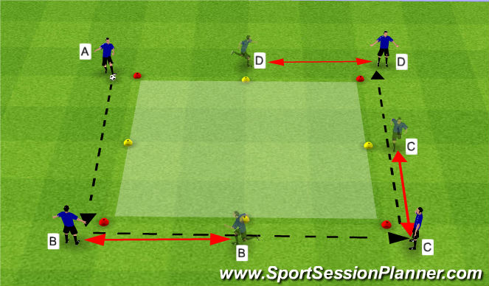

- 10x10 Box with cone markers half way between cones
- ball is passed to players' right around square, before ball is received player must get to the halfway cone to the player's right
*two touches, open up with the inside of right, pass with the inside right: touch-step-pass
*tight first touch, open up with first touch so not to pass through middle of the square
*communication, asking for every pass and communicating where passes need to be played
*timing of runs: players should be moving when they receive the ball

Progression 1- go in other direction: touches and passes with left foot, player moves to cone on their left
Progression 2- open up with the outside of foot
Progression 3- races to make it competitive. Race to 8 full rotations around square

Passing Squares Phase II

- 10x10 Box with cone markers half way between cones
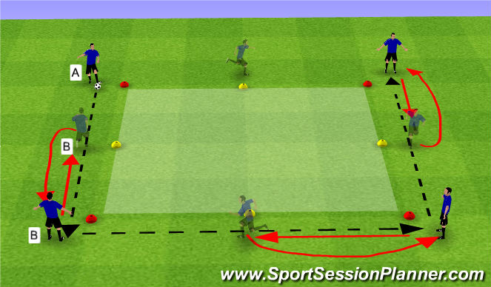

- player B receiving ball checks towards the ball, as player A is about to play ball player B opens up and bends run toward the red cone he came from to receive the ball that is played in front of him
- two touches
*timing of run and bending run away from square to open up a bigger target for passer to hit

Progression 1- go in other direction
Progression 2- races to make it competitive. Race to 8 full rotations around square

Passing Squares Phase III

- 2 Balls, 1 player (B) starts in the middle
- Player A passes to player B who knocks ball down for A to come get and play one touch to player C. Player B then joins line that A came from. D plays into player A who knocks ball down for D to come get it and play one touch to E. Player A joins line player D came from.
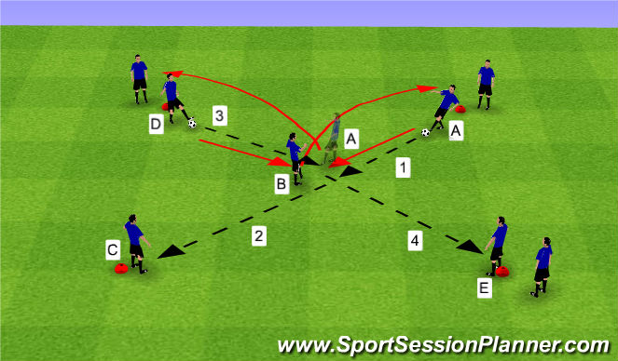

*good 1 touch passes on the ground
*as soon as ball is played from middle to the outside the next ball should be coming in right away
*how quickly can we move the ball
*think ahead and be ready for the next ball

Passing Square Phase IV

Organization
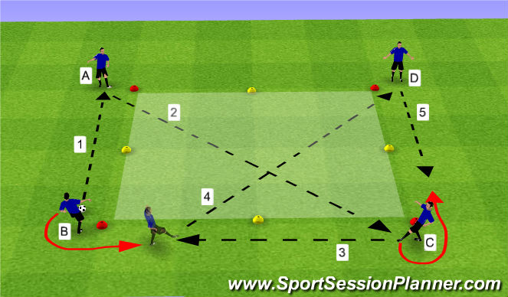

- 12x12yrd square with starting positions at corners
- Player B lays ball back to player A, player A plays diagonal in 1 touch if possible to player C, player C lays ball back to player B who has spun off to come get ball with pace, player B plays diagonal ball to player D, player D lays ball back to player C
- Sequence repeats

Rotation: A-B-C-D-A

Coaching Points
*move the ball as quickly as possible, mistakes are expected if they are pushing themselves to play faster
*play in 1 touch when possible
*play the ball with pace, over-hit the ball
*check shoulder before and when the ball is on it's way to you

Passing Squares Phase V

Organization
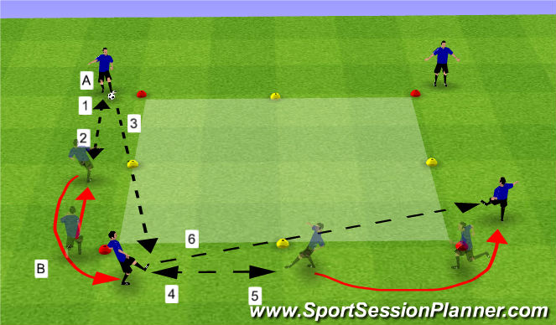

- 12x12yrd square with starting positions at corners
- Player B lays ball back to player A, player A plays diagonal in 1 touch if possible to player C, player C lays ball back to player B who has spun off to come get ball with pace, player B plays diagonal ball to player D, player D lays ball back to player C
- Sequence repeats

Rotation: A-B-C-D-A

Coaching Points
*move the ball as quickly as possible, mistakes are expected if they are pushing themselves to play faster
*play in 1 touch when possible
*play the ball with pace, over-hit the ball
*check shoulder before and when the ball is on it's way to you

