
MULTI-SKILLS
Activity Card
GEDLING

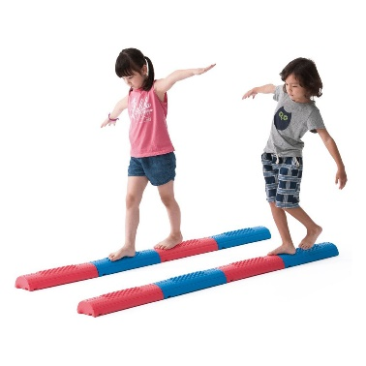
Balance Activity - Walk the Line

Pick your level

Challenge Level - Green
Walk the beam with support from your teacher / friend

Challenge Level - Amber
Walk the beam without any help

Challenge Level - Red
Walk the beam while balancing a bean bag on your head

Measure your success
- How far can you travel before stepping off the beam?
- Can you walk the whole beam without support?
- Did you manage to keep the bean bag on your head?
- How quickly can you walk the beam?

GEDLING
MULTI-SKILLS
Activity Card

Balance Activity – Stork Balance

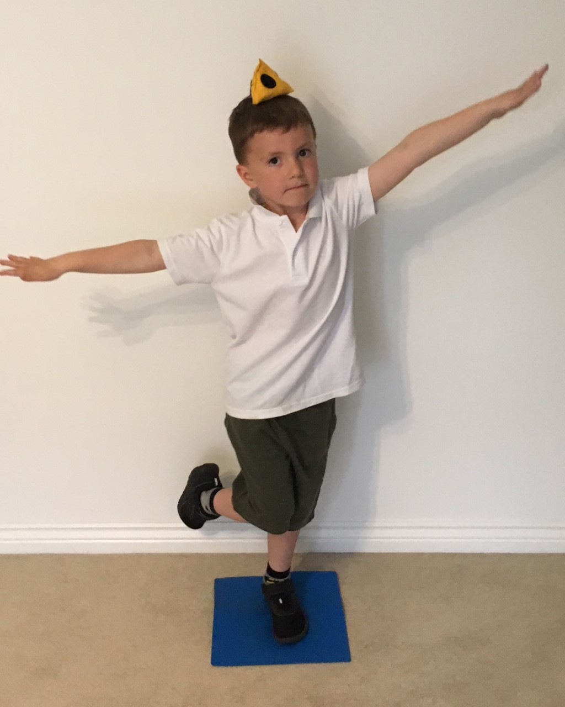

Pick your level

Challenge Level - Green
Balance on one leg for 20 seconds with support from your teacher / friend

Challenge Level - Amber
Balance on one leg for as long as possible without any help

Challenge Level - Red
Try balancing on the other leg or with a bean bag on your head

Measure your success
- Did you last the whole 20 seconds?
- How long can you balance without having to put your foot down?
- Can you balance for the same amount of time on each leg?
- Did you manage to keep the bean bag on your head?

MULTI-SKILLS
Activity Card
GEDLING

Balance Activity – Gym Ball Balance

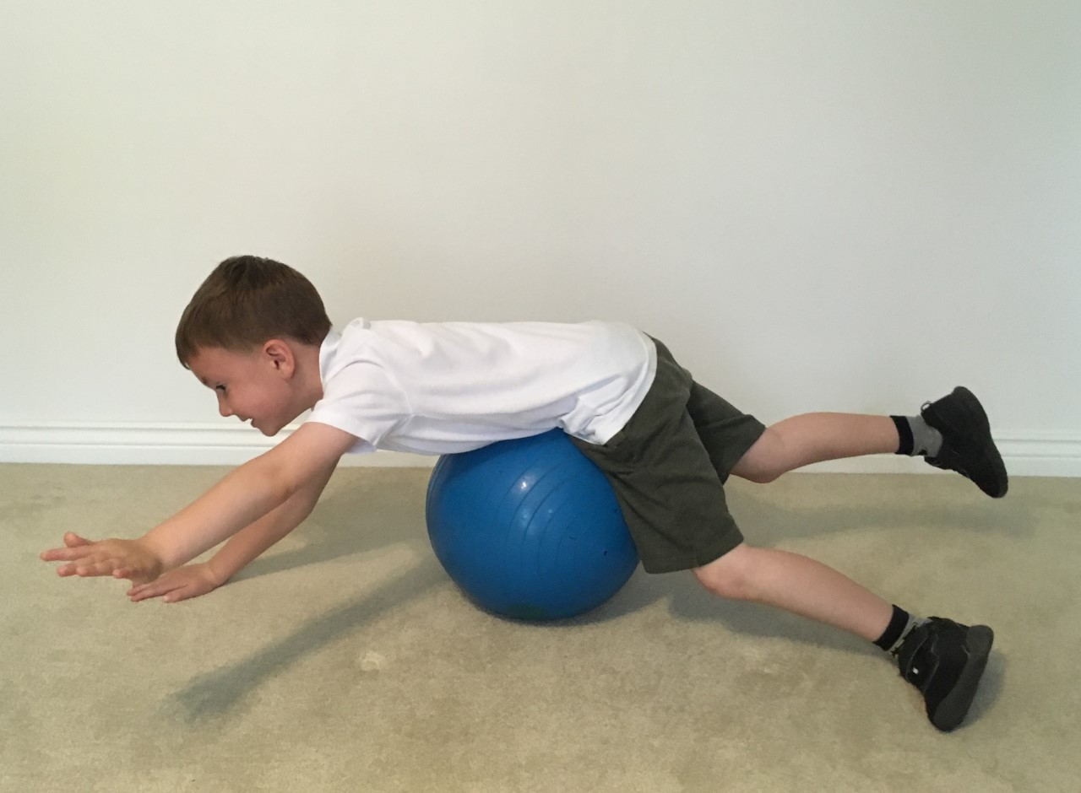

Pick your level

Challenge Level - Green
Balance on the ball with 2 points of contact on the floor

Challenge Level - Amber
Balance on the ball with 1 point of contact on the floor

Challenge Level - Red
Balance on the ball without touching the floor

Measure your success
- How long can you balance without having to put your feet / hands down?
- Did you challenge yourself to balance with fewer points of contact?
- Did you find the best way to lay or sit on the ball to stay balanced?
- Were you able to keep the ball from rolling?

MULTI-SKILLS
Activity Card
GEDLING

Jump Activity – Standing Long Jump

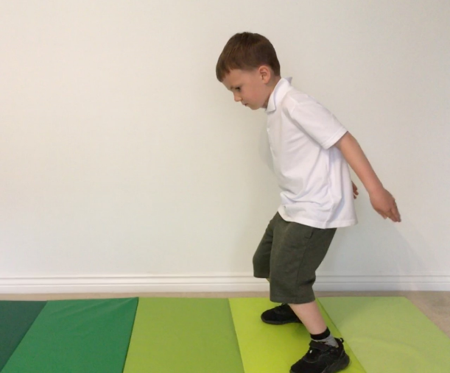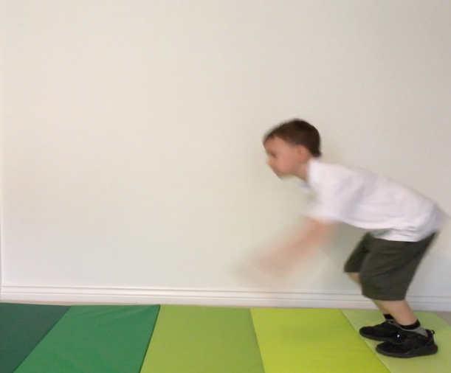

Pick your level

Challenge Level - Green
Jump as far as you can – remember to take off and land on two feet

Challenge Level - Amber
Increase your jump distance by bending your legs and swinging your arms

Challenge Level - Red
Aim to jump more than 1m without losing your balance

Measure your success
- Did you land on your feet rather than your knees or bottom?
- Did you jump further when bending your knees and swinging your arms?
- How far did you jump?
- Did you jump further with a little practice?

GEDLING

MULTI-SKILLS
Activity Card

Jump Activity – Jump and Reach

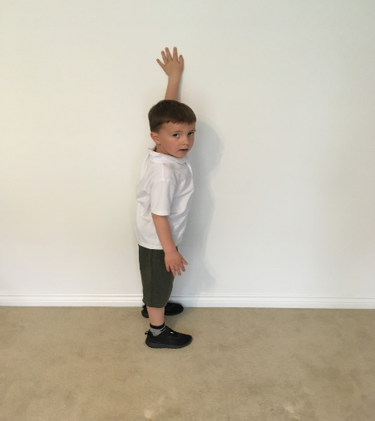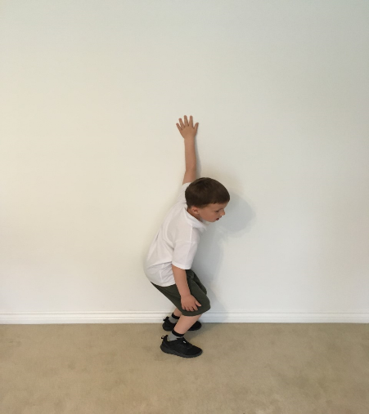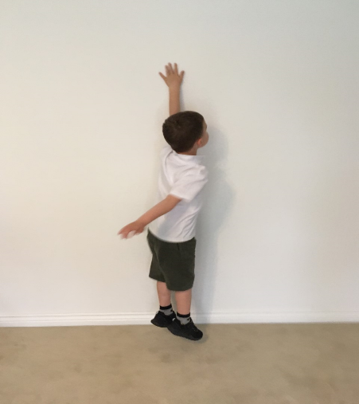

Pick your level

Challenge Level - Green
Aim to reach the next colour on the rainbow when jumping and reaching

Challenge Level - Amber
Aim to reach two colours up on the rainbow chart when jumping and reaching

Challenge Level - Red
Aim for the colours at the top of the rainbow chart when jumping and reaching

Measure your success
- Did you reach the next colour up?
- Did you challenge yourself to jump as high as you can?
- What colour did you touch on the rainbow chart?
- Can you jump higher facing forwards or side-on?

GEDLING

MULTI-SKILLS
Activity Card

Jump Activity – Speed Bounce

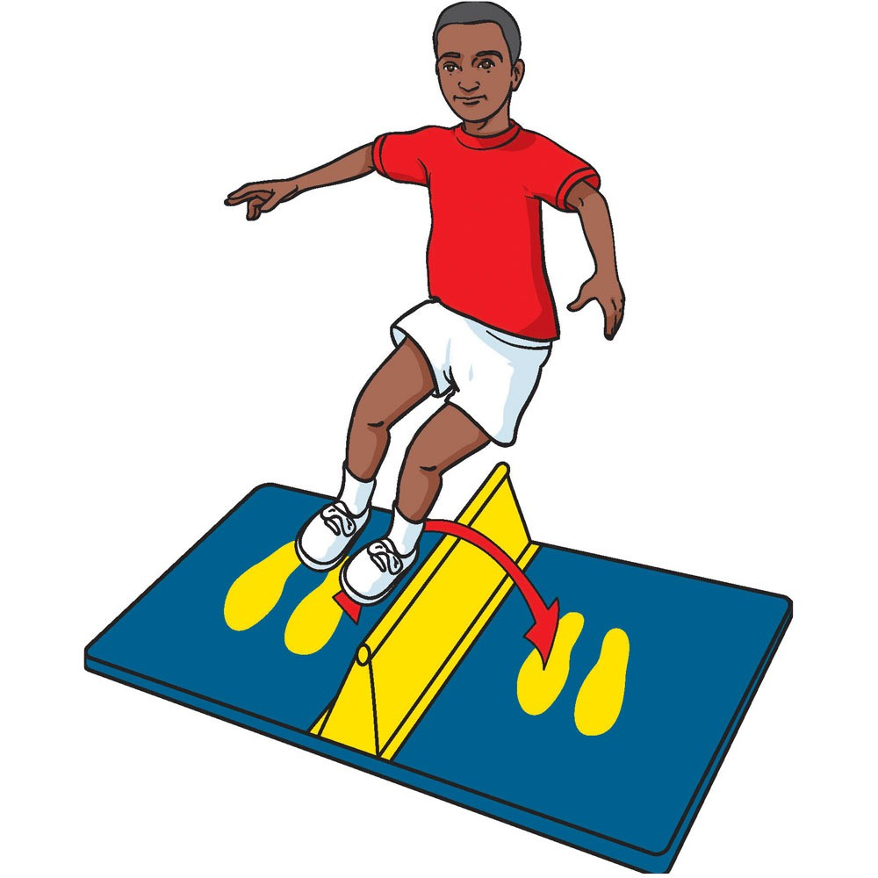

Pick your level

Challenge Level - Green
Use an alternating step action to jump over the line

Challenge Level - Amber
Use a double footed jump action to jump over the line

Challenge Level - Red
Use a double footed jump action to jump over the wedge

Measure your success
- How many times did you move from side to side?
- Did you use a double footed jump every time you crossed the line?
- Did you manage to jump the wedge without clipping it?
- Did you manage to improve your score or technique the second time you tried the task?

GEDLING

MULTI-SKILLS
Activity Card

Throw Activity – Target Throw

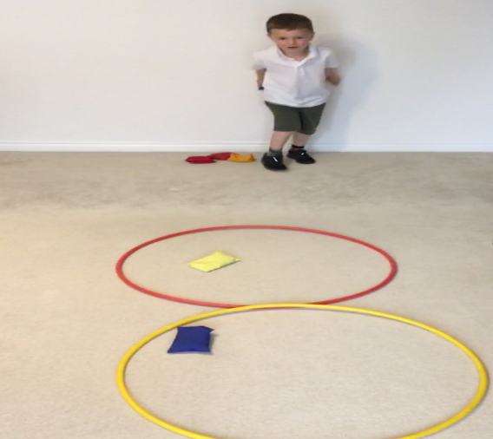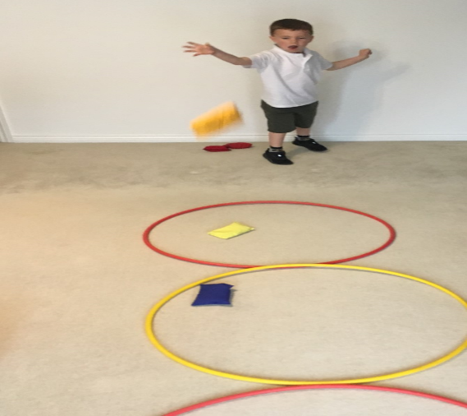

Pick your level

Challenge Level - Green
Aim to get at least one bean bag in the closest hoop

Challenge Level - Amber
Aim to get at least one bean bag in the middle hoop

Challenge Level - Red
Aim to get one bean bag in each hoop

Measure your success
- Did you manage to get a bean bag in any of the hoops?
- Were you able to get bean bags into more than one hoop?
- Did you get a bean bag in each hoop?
- How many bean bags in total did you get into the hoops?

GEDLING

MULTI-SKILLS
Activity Card

Throw Activity – Wall Rebound

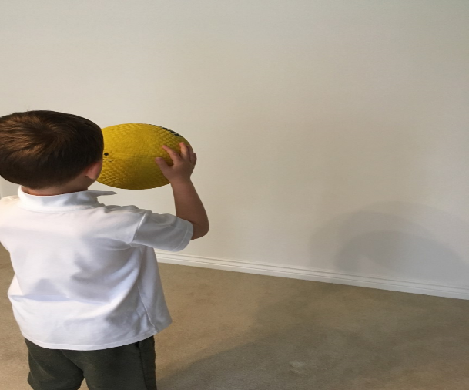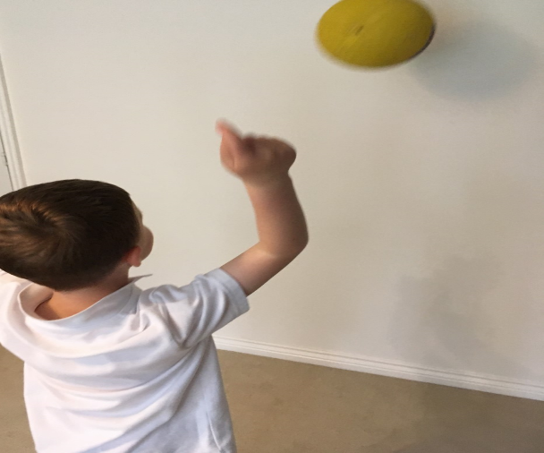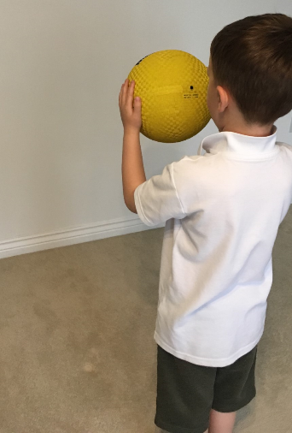

Pick your level

Challenge Level - Green
Stand close to the wall, throw the ball at the wall and catch it as it rebounds

Challenge Level - Amber
Challenge yourself to throw and catch 5 rebounds in a row

Challenge Level - Red
Move further away from the wall, trying the activity using a smaller ball

Measure your success
- Did you manage to catch the rebounding ball before it hit the floor?
- How many rebounds were you able to catch in a row?
- Were you able to throw and catch from further away?
- What type of ball was easiest to throw and catch?

GEDLING

MULTI-SKILLS
Activity Card

Throw Activity – In the Basket

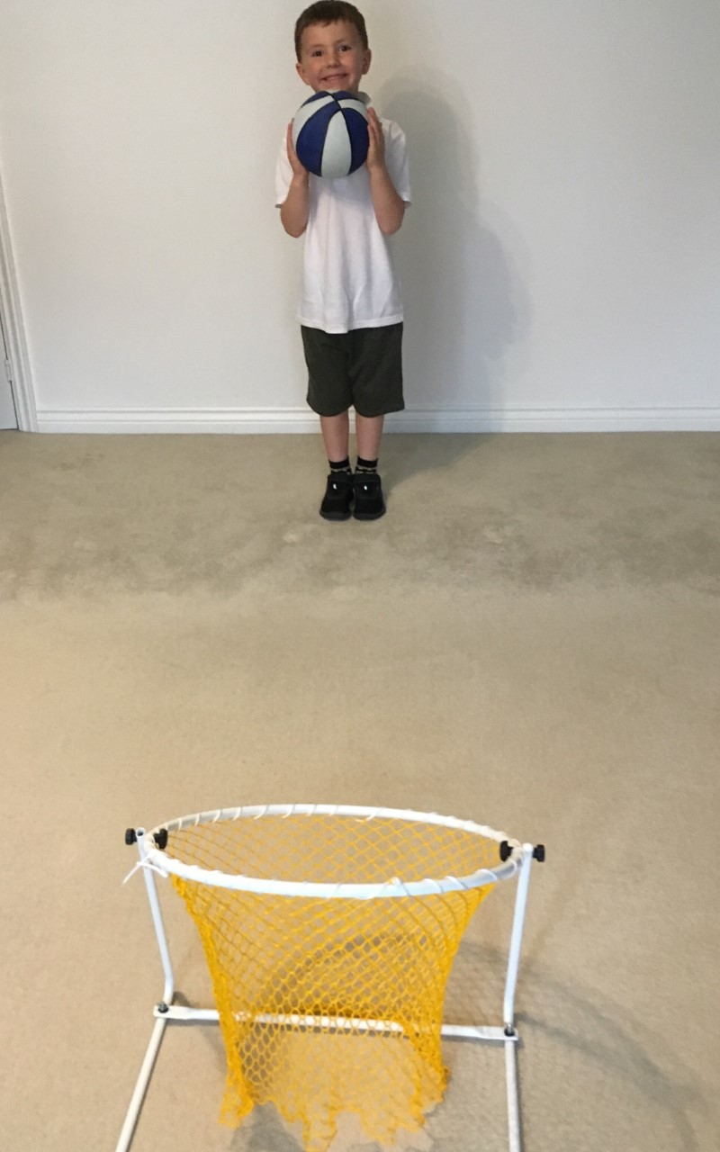
Pick your level

Challenge Level - Green
Throw the ball at the basket

Challenge Level - Amber
Aim to score at least one basket

Challenge Level - Red
See how far away you can stand from the basket and still score a basket

Measure your success
- Did your ball hit the basket?
- Were you able to score a basket?
- How many baskets were you able to score?
- Could you still score a basket when standing further away?

MULTI-SKILLS
Activity Card
GEDLING

Kick Activity – Slalom Dribble

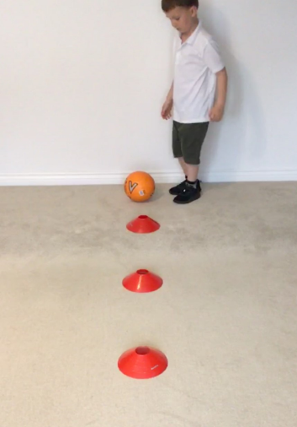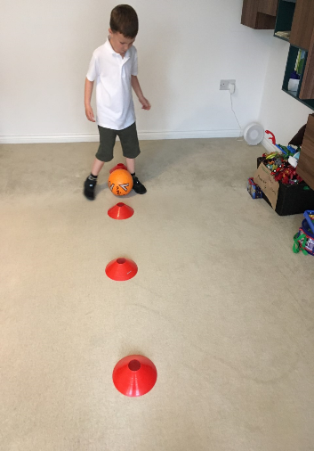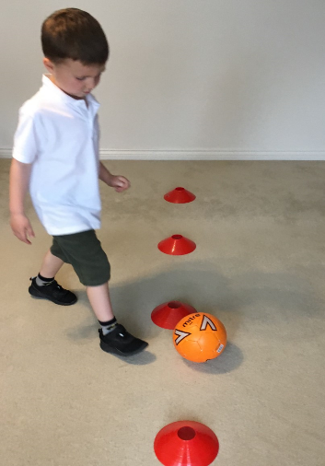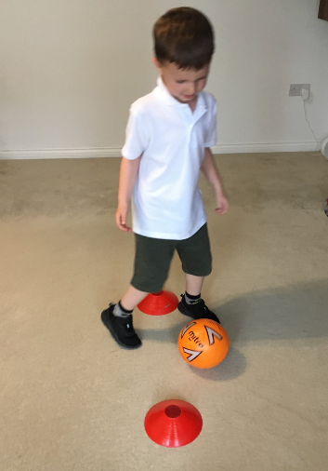

Pick your level

Challenge Level - Green
Dribble the ball through the cones and kick it back to the next person

Challenge Level - Amber
Aim to keep the ball close to your feet and under control. When kicking the ball back, chase it and stop it half way before returning it to the next person

Challenge Level - Red
Dribble through the cones using one foot, then dribble back using the other

Measure your success
- Did you weave the ball through every cone?
- Were you able to keep the ball under control and close to your feet?
- Can you dribble with both feet?
- How fast can you complete the task?

MULTI-SKILLS
Activity Card
GEDLING

Kick Activity – Skittle Scatter

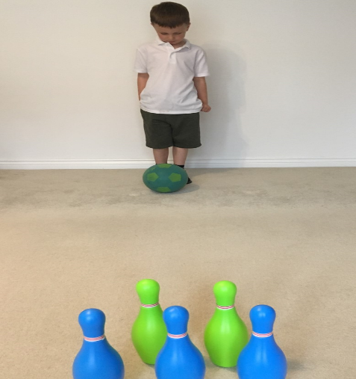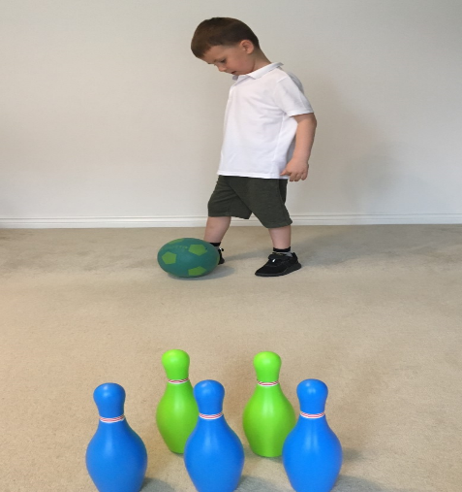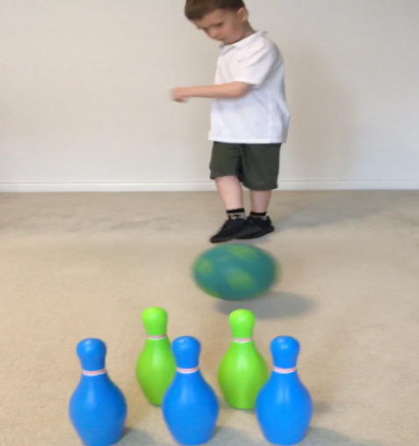

Pick your level

Challenge Level - Green
Aim to make contact with at least one skittle

Challenge Level - Amber
Knock down as many skittles as possible using your preferred foot

Challenge Level - Red
Try knocking the skittles over from further away or using your weaker foot

Measure your success
- Did you aim the ball accurately?
- How many skittles were you able to knock over?
- Could you still hit the skittles when standing further away?
- Could you hit the skittles when kicking with your weaker foot?

MULTI-SKILLS
Activity Card
GEDLING

Kick Activity – Keep it Up

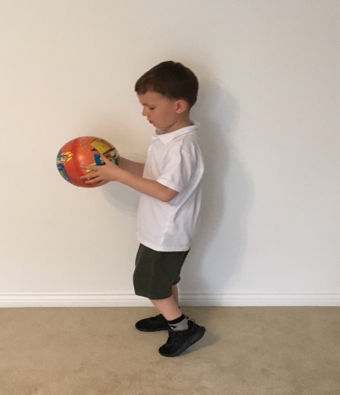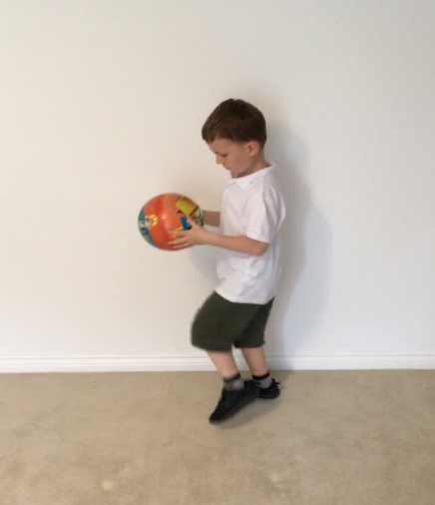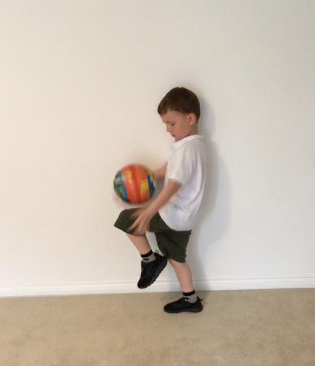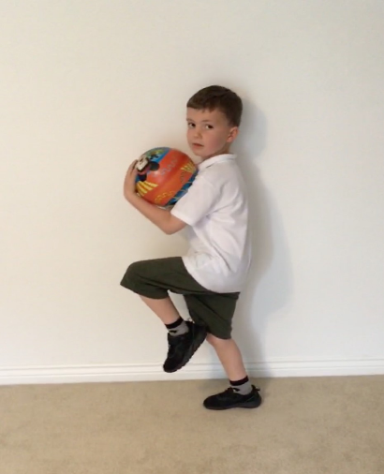

Pick your level

Challenge Level - Green
Drop the ball onto your knee and the catch it with your hands

Challenge Level - Amber
Try using only your knee to keep the ball up for as many bounces as possible

Challenge Level - Red
Use a combination of knees and feet to keep the ball bouncing as long as possible

Measure your success
- Did you catch the ball as it rebounded off your knee?
- How many bounces did you get before losing control of the ball?
- Were you able to use both your knees and feet to keep the ball bouncing?
- Did you practice the task on both sides?

MULTI-SKILLS
Activity Card
GEDLING

Agility Activity – Hurdle Hop

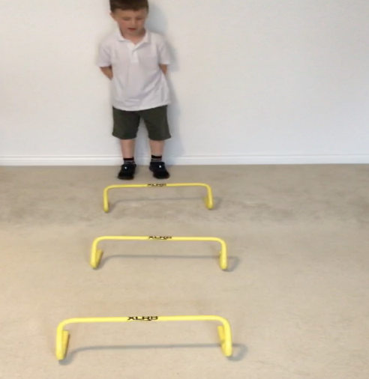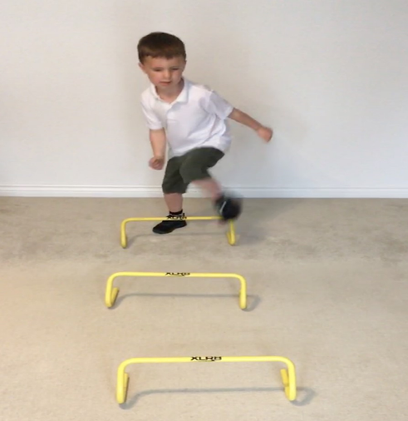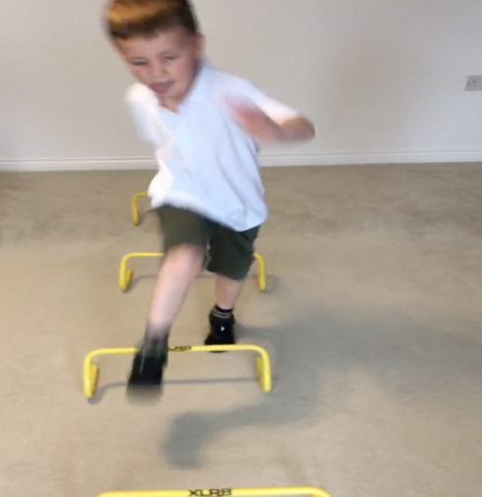

Pick your level

Challenge Level - Green
Leap over all the small hurdles as you run from one cone to the other

Challenge Level - Amber
Leap over all the medium size hurdles as you run from one cone to the other

Challenge Level - Red
Leap over all the large hurdles as you run from one cone to the other

Measure your success
- Did you step or leap over the hurdles?
- Can you get from one cone to the other without touching any of the hurdles?
- Did you challenge yourself to try hopping the larger hurdles?
- How fast were you getting from one side to the other?

GEDLING

MULTI-SKILLS
Activity Card

Agility Activity – Illinois Agility

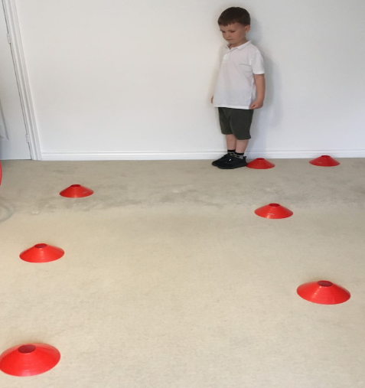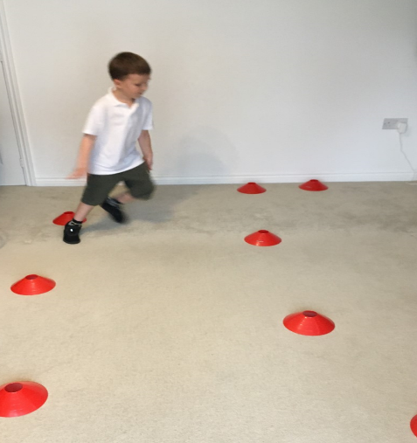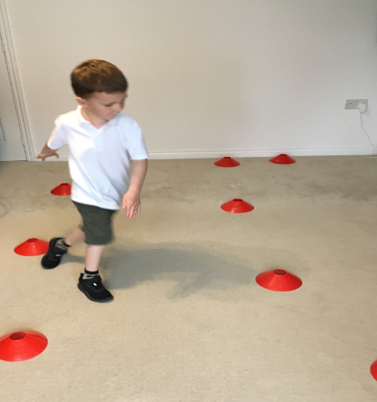

Pick your level

Challenge Level - Green
Zig zag through the cones and sprint back to the start

Challenge Level - Amber
Try to touch the cones with alternate feet as you zig zag across the course

Challenge Level - Red
Try to touch the cones with your hand as you zig zag across the course

Measure your success
- Did you manage to run round every cone?
- Were you able to touch each cone with your foot / hand?
- Did you challenge yourself to try a harder ‘challenge level’ on your second go?
- How fast did you complete the course?

GEDLING

MULTI-SKILLS
Activity Card

Agility Activity – Hopscotch

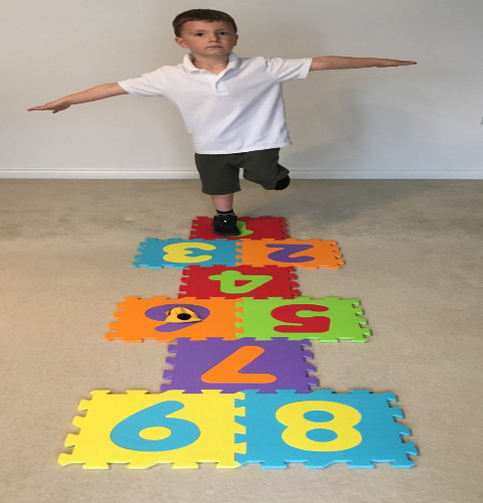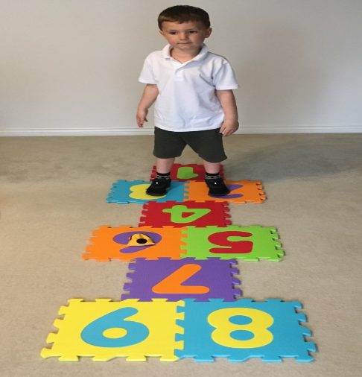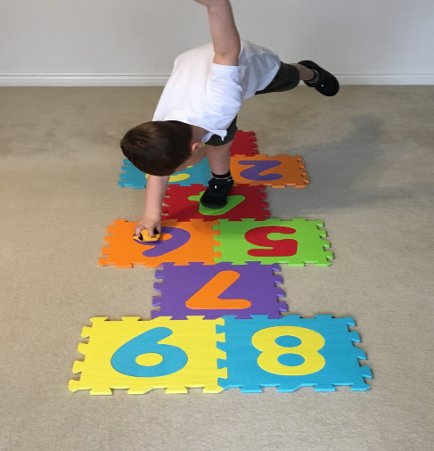

Pick your level

Challenge Level - Green
Hopscotch to the end and back without stopping

Challenge Level - Amber
Throw the bean bag and miss out the square it lands in, pick the bean bag up while standing on one foot, then complete the course

Challenge Level - Red
Hop scotch traveling forward one way and backwards the other

Measure your success
- Were you able to move from a hop to a jump without getting confused
- Can you pick the bean bag up while standing on one leg?
- Can you hop scotch backwards as well as forwards?
- How fast were able to get to the end and back?

