Week one – activity two. Reconnecting the Rosa family. Try the activity before looking at answers. Practice saying the words.
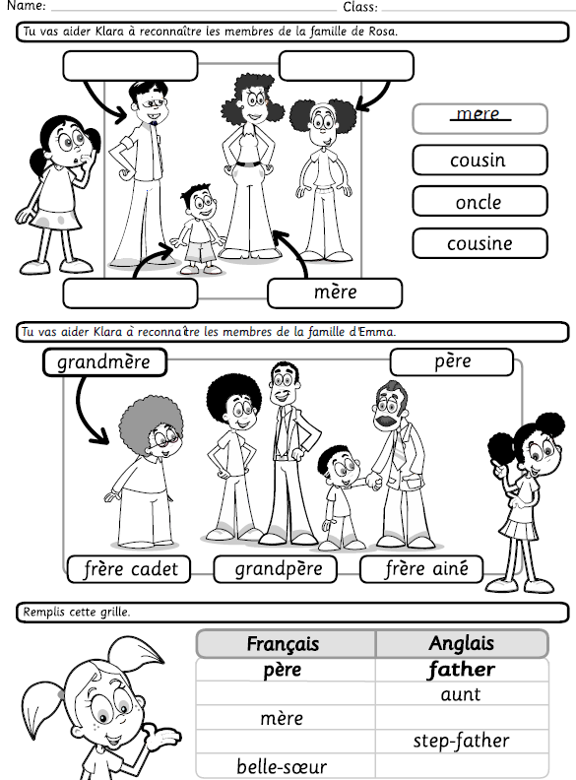

Answer sheet


