FRENCH ACTIVITY THREE
Learning numbers. Sten en veut means ‘Sten wants…’
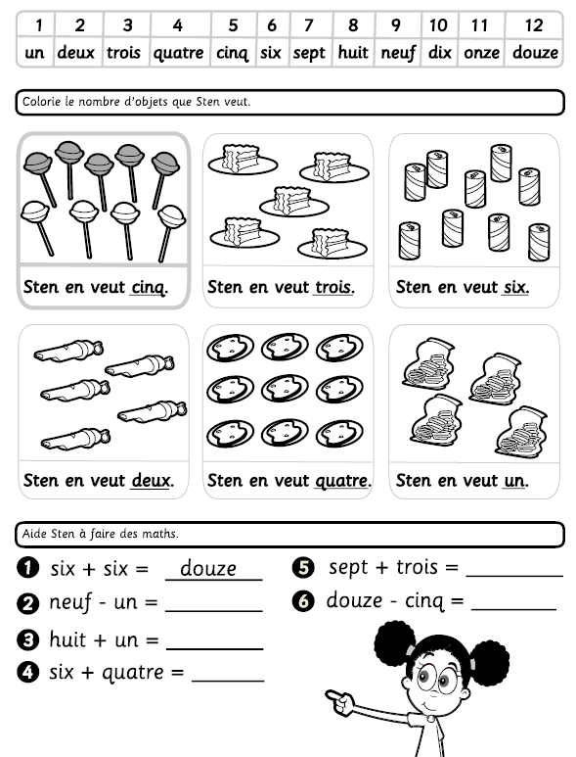

The answer sheet.
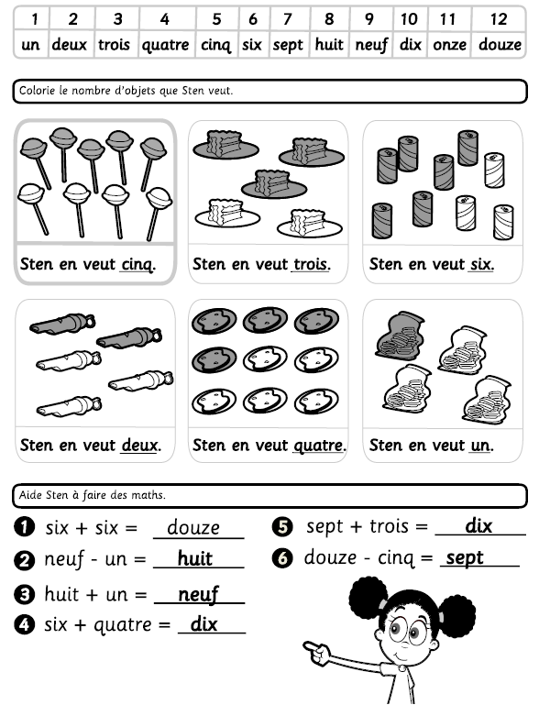
Why not try some more sums in French.

