Observation Trail

Location specific questions | Track along the trail questions
 | - How many windows did you pass on your trail?
 | - What colour lines are marked on the playground?
 | - Where is the tallest tree located?
 | - List any bugs or insects that you spotted on your trail?
 | - How many gates did you pass?
 | - Where is the best place to sit if you get tired on the trail?
 | - How many people did you pass on your trail?

Scavenger Hunt Checklist
 | 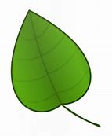  A Leaf |  |  | 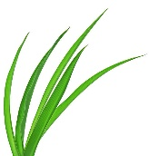  A Blade of Grass
 | 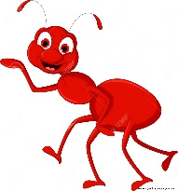  An Ant |  |  | 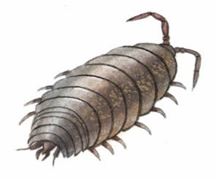  A woodlice
 |   A ball |  |  |   A sign
 | 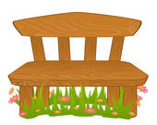  Somewhere to sit |  |  | 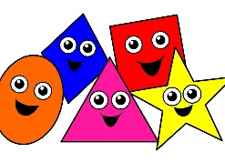  3 different shapes
 |   A flower |  |  | 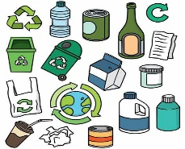  Something recyclable
 | ?  Something red |  |  |   Something you usually find indoors
 | 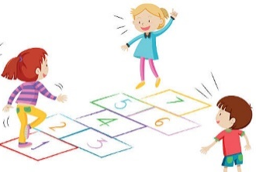  A game to play |  |  | Something not on the list

