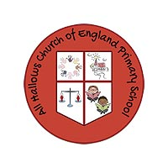


Phonics Policy

This policy contains the aims and working practice for Phonics at
All Hallows C of E Primary School

Phonics Lead teacher: Louisa Radford and Martin Mulqueen

Policy agreed by staff:

Policy agreed by governors:

Date: July 2022

Policy to be reviewed:

Introduction
At All Hallows C of E Primary School, we believe that early, effective phonics teaching and learning is essential for achieving high attainment in reading and writing. Additionally, children’s confidence with phonics is integral to the curriculum and is used in all subjects. Achievement in this area benefits every area of pupils’ development and the school as a whole.
This policy is aimed at reinforcing a consistent, high quality approach to the teaching of phonics across the Early Years Foundation Stage (EYFS), Key Stage One and on into Key Stage two for children who require further support.
Aims

- To teach children aural discrimination, phonemic awareness, alliteration and rhyme to aid reading, writing and spelling development.
- To encourage the use of segmenting and blending so that decoding skills provide a sound foundation for reading, writing and spelling.
- To ensure that the teaching of phonics is lively, interactive and inclusive.
- To enable children to use their phonological awareness across the curriculum.
- To ensure that children know the 44 phonemes within the English language.
- To teach children to recognise the graphemes within words and associate them with the appropriate phoneme when reading.
- To provide children with strategies to identify and decode Common Exception and High Frequency words.
Objectives

- To provide consistent, high quality phonics teaching that ensures all children have a strong foundation upon which to tackle the complexity of reading and writing.
- To ensure that teaching of synthetic phonics is systematic and progressive throughout the Foundation stage, Key Stage One and Key Stage Two for those children needing interventions to support phonemic knowledge and understanding.
- To ensure that children have a sound phonetic knowledge, understanding and skills so that they can decode words with confidence and engage with higher order reading and writing skills.

Teaching and Learning

At All Hallows C of E Primary we use DFE listed, Monster Phonics as a whole-class scheme. ‘Monster Phonics’ is a rigorous, systematic synthetic programme developed by Ingrid Connors, a primary teacher, phonics specialist and audiological scientist. All of the resources within the programme are mapped against the Letters and Sounds phases 1 to 6 and the KS1 Spelling Curriculum.

Different to any other scheme, Monster Phonics uses colour to consistently code for key graphemes in English. Colour shows children how to pronounce the most difficult aspects of reading. It is unique in that it uses character (monster) phoneme cues and colour coding to represent the long vowel sounds, silent letters and tricky letters. With Monster Phonics, spellings are more memorable and learning to read and spell becomes exciting and fun!

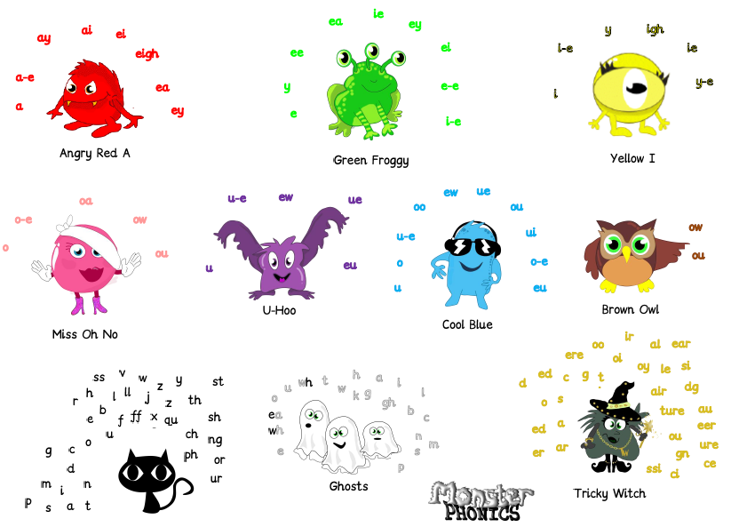

The innovative colour-coding system aims to accelerate learning to read and spell. It is the only scheme that uses colourcoding for sound and audio-visual cues (monsters) to bring phonics teaching to life. Monster Phonics best supports children with dyslexia because it is by far the most multisensory scheme available.
Visual learners benefit from the visual memory of colour in words. EAL learners have pronunciation support for every word that they learn. Monster Phonics highlights the existence of the open syllable spelling of long vowels A, E, I, O and U, such as in be, no, apron, open, me which many young learners misspell.

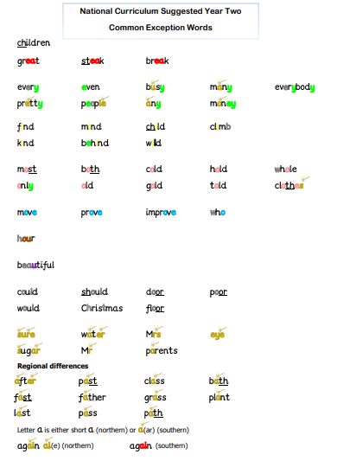
Example of Yr 2 Common exception wo

Aspect 1 - General sound discrimination - environmental
The aim of this aspect is to raise children's awareness of the sounds around them and to develop their listening skills. Activities suggested in the guidance include going on a listening walk, drumming on different items outside and comparing the sounds, playing a sounds lotto game and making shakers.

Aspect 2 - General sound discrimination - instrumental sounds
This aspect aims to develop children's awareness of sounds made by various instruments and noise makers. Activities include comparing and matching sound makers, playing instruments alongside a story and making loud and quiet sounds.

Aspect 3 - General sound discrimination - body percussion
The aim of this aspect is to develop children's awareness of sounds and rhythms. Activities include singing songs and action rhymes, listening to music and developing a sounds vocabulary.

Aspect 4 - Rhythm and rhyme
This aspect aims to develop children's appreciation and experiences of rhythm and rhyme in speech. Activities include rhyming stories, rhyming bingo, clapping out the syllables in words and odd one out.

Aspect 5 - Alliteration
The focus is on initial sounds of words, with activities including I-Spy type games and matching objects which begin with the same sound.

Aspect 6 - Voice sounds
The aim is to distinguish between different vocal sounds and to begin oral blending and segmenting. Activities include Metal Mike, where children feed pictures of objects into a toy robot's mouth and the teacher sounds out the name of the object in a robot voice - /c/-/u/-/p/ cup, with the children joining in.

Aspect 7 - Oral blending and segmenting
In this aspect, the main aim is to develop oral blending and segmenting skills.
To practise oral blending, the teacher could say some sounds, such as /c/-/u/-/p/ and see whether the children can pick out a cup from a group of objects. For segmenting practise, the teacher could hold up an object such as a sock and ask the children which sounds they can hear in the word sock.
The activities introduced in Phase 1 are intended to continue throughout the following phases, as lots of practice is needed before children will become confident in their phonic knowledge and skills.

Once the staff within Nursery feel that the children are ready they begin to use SATPIN to orally blend and segment words before moving on to visually blending and segmenting to read VC and CVC words.

Phonics lessons at All Hallows C of E Primary use the following sequence in all lessons:

Revise and Revisit
Teach
Practise
Apply

Based on Research and support from our local English hub, each phonic lesson starts with a complete revisit of all the sounds that the children have been taught so far.

In the Early Years Foundation stage, this is achieved by using a fast-paced flashcard review. In Key Stage 1 this is achieved using a Monster Phonics learning wall/chart to review all the sounds that have been previously taught since EYFS up to a current point.


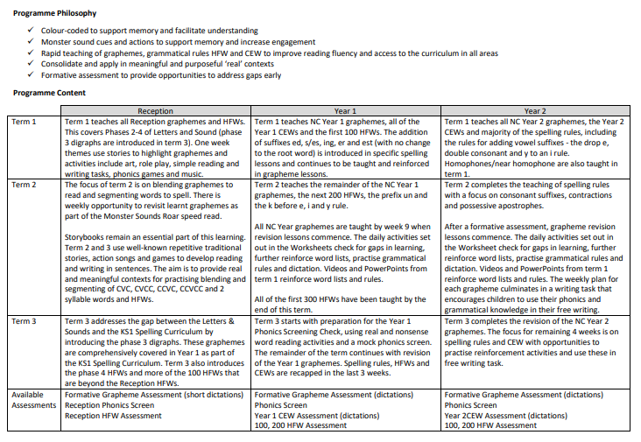

Assessment

Assessment within each year groups takes place each half term in line with our school’s half termly data points. Assessment in each year groups differs slightly.

EYFS- Half termly assessment checks:
Grapheme/ Phoneme Correspondence (GPC), High Frequency Word recognition and ability to blend and segment.

Summer 2- All reception pupils are assessed using the first 20 words from past Phonic Screening Papers. This is in preparation and planning for transition to Year1.

Year 1 & Year 2 Resit children- These pupils are assessed using Past phonic screening papers. Assessments are carried out by their class teacher and a selection are done by the phonics lead and SLT for quality assurance purposes.

Target children (bottom 20%) from the cohort are assessed using addition assessments from Monster Phonics.

Year 2 (not re-sits) and Key Stage 2 Target children- Pupils are assessed using formative grapheme assessments (dictations) and using the Year 2 CEW Assessment (dictations)

Information from all of our assessments feed back into Teaching and learning so that gaps are identified and robustly addressed through additional intervention and targeted support within the classroom.

Reading Books
Our phonetically decodable books are also fully matched to the Monster Phonics Programme. Monster Phonics books ensure that children are reading using phonics that has been taught. Each book focuses on a key grapheme and ability-appropriate high-frequency words.
Our children practise reading a Monster Phonics book in their guided reading group. At the end pf the school week, the book is sent home for sharing.
Phonic keywords and high-frequency word practice boxes at the start of each book help children to read the story with confidence. Stories include wow words and centre around the popular monster characters. Each book ends with questions to develop comprehension skills.
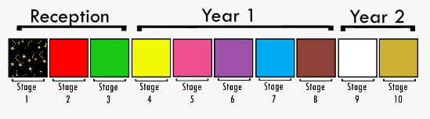
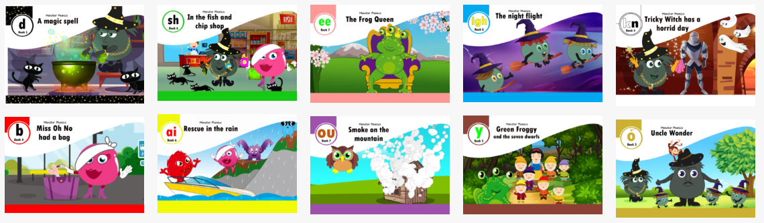

Intervention

If children need intervention or booster groups to reach age-related expectations in phonics, this is provided in addition to the daily phonics session so that as many children as possible can access their year group learning objectives and reach age appropriate outcomes.

Special Educational Needs and Disability

At All Hallows C of E Primary we use planning and teaching flexibly in order to ensure individual needs are met and children achieve their full potential.

- Differentiation through tasks to stretch and Challenge we appropriate,
- Support using adults and additional resources.

Equal Opportunities

We are committed to providing a teaching environment conducive to learning. All children are valued, respected and encouraged to take risks in order to achieve regardless of ability, race, gender, religion, social background, culture or disability.

Parent Partnership

At All Hallows C of E Primary we strongly believe that positive partnerships between staff and parents/carers are paramount in ensuring that children achieve their full potential. With this in mind we:

- Parent/carers are invited into school to an information meeting to discuss how we teach phonics in school and to learn how they can support their children at home.
- Year 1 Parents/carers are invited into school to receive information about the Phonic Screening Check as well learning how to support their children are home.
- We send home online links to the phonetically decodable reading books for parents/carers to share with their child.
- In addition to regular Parents Evenings we strongly encourage parents to meet with teachers if they have any concerns about their child’s learning.

