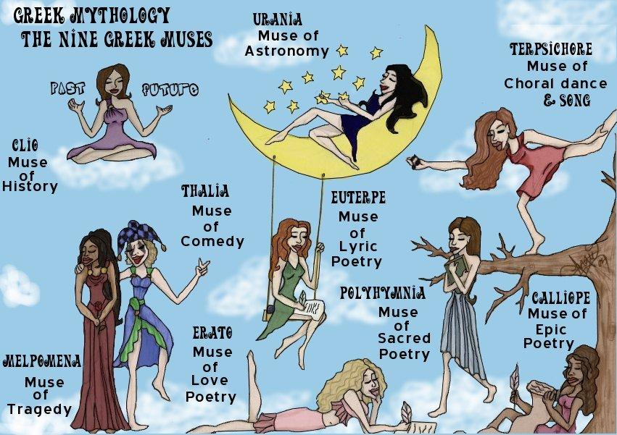
THE 9 MUSES OF ART
Clio

Clio is the muse of history. She is sometimes seen with a scroll in her hand. She had one son called Hyacinthus who was killed by Apollo god of healing, prophecies, the sun, archery, music, and poetry by throwing a discus in his face (even though he loved Hyacinthus). In Greek, the name Clio translates to kleio which means “to make famous”.

Urania

Urania is the muse of astronomy. She is commonly portrayed with a globe. She was the mother of the musician Linus. During the renaissance she was considered muse of many famous poets including John Milton. Some say she can tell the future by looking at the way stars are arranged.

Terpsichore
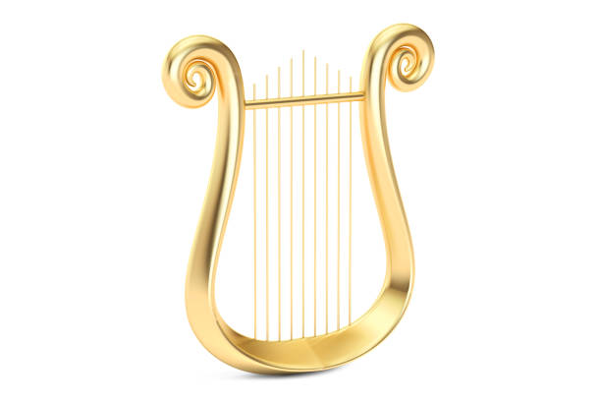
Terpsichore is the muse of dance and song. She is usually depicted sitting down holding a lyre in her hands. She is known to be the creator of the deadly sirens. She is perhaps the most widely known muse on earth. The adjective terpsichorean is based on Terpsichore.
Melpomene
Melpomene was the muse of chorus but was changed to the muse of tragedy (which she is most famous for). She was recognized by the weeping mask she holds. Her name comes from the Greek verb melpô which means ‘to celebrate with dance’.


Thalia

Thalia was the muse of comedy. Like her sister Melpomene, Thalia has a mask as a symbol but instead of it weeping it’s a laughing mask. Thalia was the mother of the Corybantes, who were armed and crested dancers. Her name in Greek is θάλλειν which means to flourish.

Erato
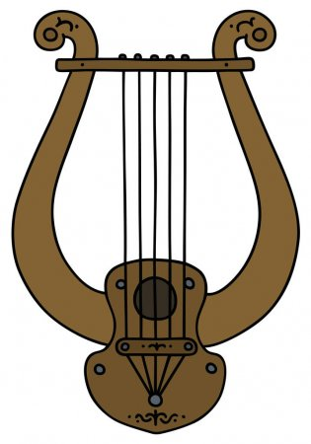
Erato is the muse of love and erotic poetry. She is usually seen holding a Cithara. Erato has the same root as Eros, the god of desire. Her name means “desired”, “beloved” or “lovely”. Kleopheme is the daughter of Erato, she’s not well known in Greek mythology.

Polyhymnia
Polyhymnia is the muse of sacred poetry and meditation. She is the only muse who doesn’t have a symbol. Polyhymnia was also described as the mother of Triptomelus, and Orpheus a famous musician. Polyhymnia’s name means much song.
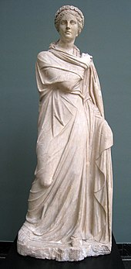

Euterpe
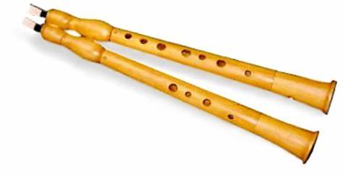
Euterpe is the muse of lyric poetry. Her symbol is the double flute and she also was said to have invented the flute and other wind instruments. She is the most cheerful and joyful muse; she is said have created pleasure. Apparently the Thracian king Rhesus is the son

Calliope

Calliope is the muse of epic poetry she is also the leader of the muses. Her symbol is the caduceus, which is also Hermes’ symbol of power. The word calliope literally means ‘‘to have a beautiful voice’’. Calliope had a son which was Hymen god of marriage.

End
I really hope you’ve enjoyed this document about the 9 muses of history, astronomy, dance, tragedy, comedy, erotic poetry, sacred poetry, lyric poetry and epic poetry.

