5 uses for Easter Egg Plastic Packaging
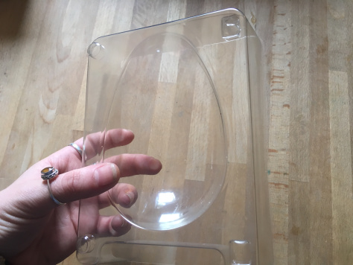
1.Make your own next time (duh!)
Seems a simple one, but by making your own next year, using the moulds from this weekend, you can experiment with your own flavours, avoid more plastic waste and save yourself at least £5 an egg in the process! Plus, technically there is nothing stopping you making chocolate eggs EVERY weekend. Just sayin’

2.Spring Garden Planters
Who knew that Easter Egg moulds could double as super easy garden pots?! All you need is a little compost, a seed or an existing plant (I used a clipping of my aloe Vera in the picture below) and you have yourself a free planter! Go for something that is relatively happy with little watering though, as drainage isn’t great in an egg mould…
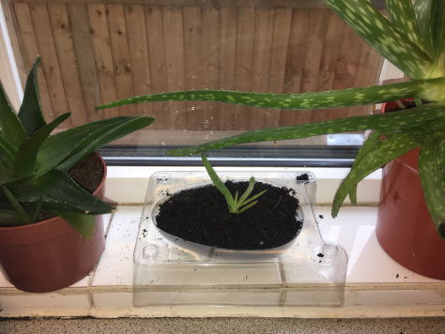

3. Jewellery/Key storage
Forget fancy ceramic bowls and organically woven cotton baskets….check out this fancy plastic egg mould storage bowl!! All you need is some pretty wrapping paper, spray paint or even a few sparkly stickers to jazz it up and hey presto you have a holder for all your treasures.
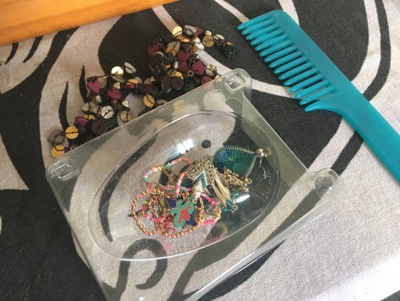
4.Gift Box
Got a nosy loved one who likes to squeeze their gifts before they’re allowed to open them? Trick your recipient with a egg shaped gift and hide whats really inside!

5.Bird Feeder
Fill your egg with seeds or water and leave somewhere high up (especially if you have cats like me!) for the birds to come and fill their bellies. If you have a particularly bee friendly garden you could also leave one near some of your pretty flower beds or blossom trees with sugar water to keep them energised on particulaly hot or busy bee days!


