Black Mamba Snakes
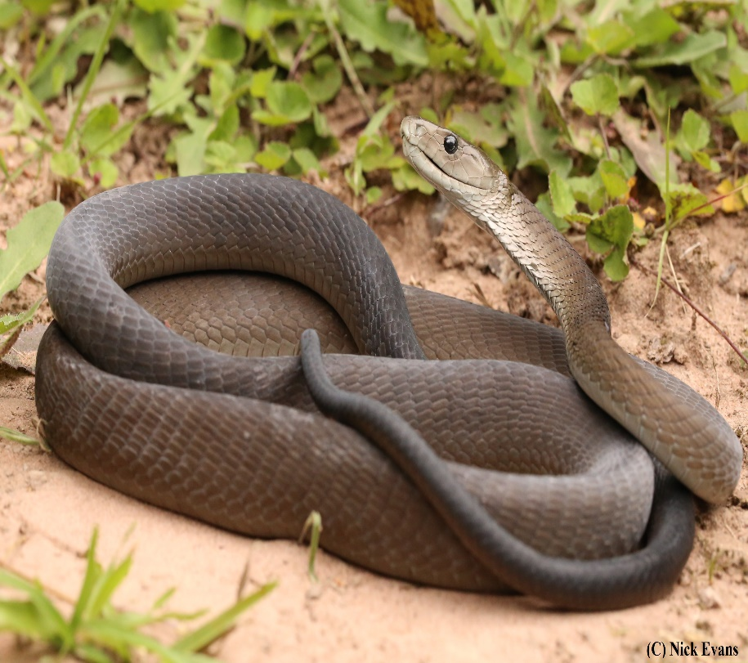
Black Mamba Quick Facts
- Black Mambas is the deadliest snake in Africa

- It is the fastest known land snake known to mankind.

- in the wild, these snakes have an average lifespan of 11 years.

The African black mamba’s bite has been called “the kiss of death”—and for good reason. It has been estimated that just 10 to 15 ml of venom from the world’s deadliest snake, triggering severe pain, vomiting, shock, and limb paralysis, can kill a person within hours. Despite a large quantity of extraordinarily strong venom, black mamba has some predators. The main predator of black Mamba is a mongoose. Other predators are birds of prey, foxes and jackals.

The black mamba is a species of extremely venomous snake, a member of the elapid family which originates from Africa. Members of this family have a wide range of sizes, from the smallest 18 cm to the longest 5.85 m. Other elapids include Najas, tiger snakes, Eastern brown snake and Furinas. Out of the 300 species of elapids most of the snakes live in trees.

Like all snakes, Black Mambas can control a bite. This means that no venom is released. Black Mambas rarely settle for one bite, though. these attacks can lead to severe blood loss. This can be just as dangerous as venom.

