By Scott
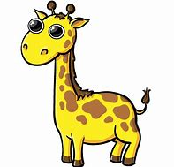
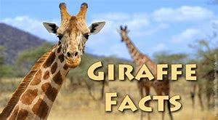

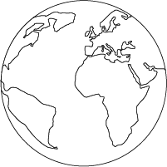

Their Habitat
Giraffes are native to Africa and like hot climates.
They like wide open spaces where they can see their predators, they also need plenty of space to roam around.
Their home range is between 8 and 50 square miles but their natural habitat is shrinking due to human activities.
About Giraffes
There are different species of Giraffe including the Reticulated Giraffe, South African Giraffe, West African Giraffe and Angolan Giraffe.
It is the tallest of all land animals and is easily spotted by its long legs and long neck.
They can live around 26 years in the wild.
They can run up to 60 kilometres per hour.
Males are called bulls and females are called cows.
Bulls can grow up to more than 5.5 metres tall and their tongues are around 0.5 metres long.

Their food
Giraffes will move to where they need to find food.
They eat leaves fruits and flowers of woody plants.
Lions, leopards, hyenas and African wild dogs try to eat them.



