The Millennium West Window

Annotate this photograph of the Millennium West Window found in All Hallows C of E Church.
Use the text to help you find all of the different details relating to this stained glass window.

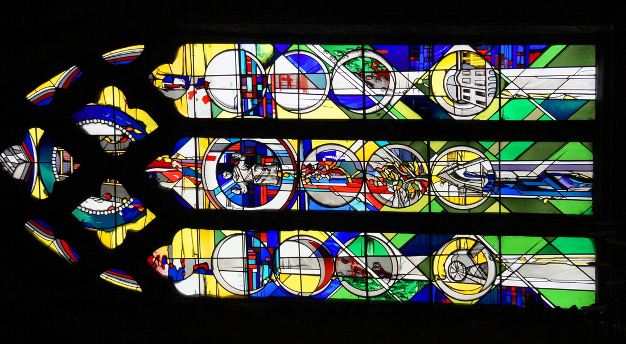

The Millennium West Window
The features of the design are contained in circular medallions which were used in medieval stained glass windows. Diagonal lines reaching up through the whole window are reminiscent of the shape of the hatchments on the wall on either side.
At the bottom there are medallions depicting scenes in Gedling at the end of the Millennium with the Colliery, the Fountain and Gedling House. They are shown with exaggerated vertical perspective to direct the eye upward. A stream of life-giving water flows from the Fountain.
A little higher in the centre is an oak tree representing the passage of time with leaves shown in the colours of all the seasons and bare branches for winter. These branches anticipate the cross. Such an oak existed in Gedling in the centre of the old cricket field to the west of the church, this area is now known as the Oake tree drive estate.
On either side are the faces of the saints of the church whose work is not yet completed and echo the two medieval stone carved heads higher up either side of the window.
Higher still is depicted the burst of energy at the Resurrection at the centre with the Moon and Sun on either side.
The central figure shows Christ in Glory at the intersection of the arms of a cross that forms a background to the whole design.
Abstract elements continue the ascending theme into the tracery.
The circle in the tracery has glass lenses around it to represent the souls of the saints of the church who have gone before us.
In the centre is the Ladder of Perfection, (Jacobs` ladder?) a medieval concept originated by Walter Hilton a monk of Thurgaton Priory in about 1380.
Around the top of the window is a rainbow symbolic of God`s covenant with man.
At the very top is the symbolic grey and white wing of a dove.
This explanation represents the thoughts of Andrew Johnson who was commissioned by All Hallows to design and build the Millennium West window in 2001.

