Calculation Policy for Mathematics



Updated September 2015

Calculations Policy
This policy should be read alongside All Hallows C of E Primary Mathematics Policy which sets out the ethos, aims, assessment and teaching and learning strategies which underpin the mathematics learning at our school. This policy was developed and written by all teachers and teaching assistants. Governors determine, support, monitor and review all school policies.

Equal Opportunities

Providing Equal Opportunities is the responsibility of the whole school community and must be reflected throughout the organisation of the school and at the heart of its ethos. The taught and hidden curriculum will provide opportunities for all pupils to thrive and at All Hallows we recognise that treating people equally does not always mean treating them the same. All curriculum subjects should be planned and marked with Equal Opportunities in mind. They should expose all of our pupils to a wide range of learning experiences and promote an awareness and curiosity about the world. Our curriculum aims to prepare all of our pupils for life in modern Britain and to be citizens of a diverse and changing world.

About our Calculation Policy

The following Calculation Policy has been devised to meet the requirements of the National Curriculum 2014 for the teaching and learning of mathematics, and is also designed to give pupils a consistent and smooth progression of learning in calculations across the school. Please note that earl learning in number and calculation in the Foundation Stage follows the ‘Developmet Matters’ EYFS document and this Calculation Policy is designed to build on progressively from the content and methods established in the EYFS.

‘Decisions about when to progress should always be based on the security of pupils’ understanding and their readiness to progress to the next stage. Pupils who grasp concepts rapidly should be challenged through being offered rich and sophisticated problems before any acceleration through new content. Those who are not sufficiently fluent with earlier material should consolidate their understanding, including through additional practice, before moving on.’ (National Curriculum 2014) With this in mind, staff at All Hallows have decided that the calculation methods taught should remain discrete to the year group stated, with the understanding that children who are not secure in a calculation method, will continue to use the method from the previous year until ready to move on.
This policy is divided into the four operations of addition, subtraction, multiplcation and division and these are sub-divided into year groups. Some of the pages contain a link to an online video clip which demonstrates calculation methods being taught- these may be useful for staff and parents to access.

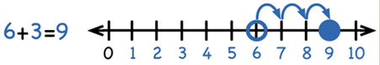
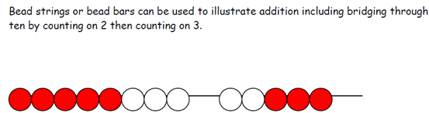



Year 1 Add with numbers up to 20

Use numbered number lines to add, by counting on in ones. Encourage children to start with the larger number and count on.

+1 +1 +1

Children should:

• Have access to a wide range of counting equipment, everyday objects, number tracks and number lines, Base 10 apparatus, Numicon and be shown numbers in different contexts.

• Read and write the addition (+) and equals (=) signs within number sentences.

• Interpret addition number sentences and solve missing box problems, using concrete objects and number line addition to solve them: 8 + 3 =
15 + 4 = 5 + 3 + 1 = + + = 6

This builds on from prior learning of adding by combining two sets of objects into one group (5 cubes and 3 cubes) in Early Years.

8 + 5

Key vocabulary: add, more, plus, and, make, altogether, total, equal to, equals, double, most,
count on, number line

Key skills for addition at Y1:

• Read and write numbers to 100 in numerals, incl. 1—20 in words
• Recall bonds to 10 and 20, and addition facts within 20
• Count to and across 100
• Count in multiples of 1, 2, 5 and 10
• Solve simple 1-step problems involving addition, using objects, number lines and pictorial representations.

Video clips: Using a range of equipment and strategies to reinforce addition statements / bonds to 10


Year 2 Add with 2-digit numbers Developing mental fluency with
addition and place value involving 2-digit numbers, then establish more formal methods.

Add 2-digit numbers and tens:

Add 2-digit numbers and ones:
Use empty number lines, concrete equipment, hundred squares etc. to build confidence and fluency in
mental addition skills.

Add pairs of 2-digit numbers, moving to the partitioned column method when
secure adding tens and ones:

23 + 34:

STEP 1:Only provide examples that do NOT cross the tens boundary until they are secure with the
method itself.

STEP 2: Once children can add a multiple of ten to a 2-digit
number mentally (e.g. 80+11), they are ready for adding pairs of
2-digit numbers that DO cross
the tens boundary (e.g. 58 + 43).

58 + 43:

STEP 3: Children who are confident and accurate with this stage should move onto the expanded addition methods with 2 and 3-digit
numbers (see Y3).
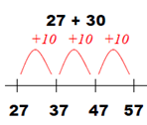
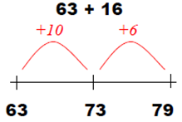
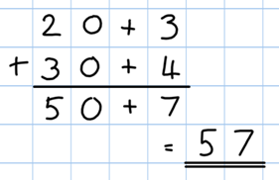
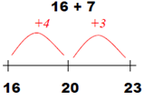
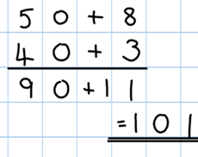

To support understanding, pupils may physically make and carry out the calculation with
Base 10 apparatus or place value counters, then compare their practical version to the written form, to help them to build an understanding of it.

Key vocabulary: add, more, plus, and, make, altogether, total, equal to, equals, double, most,
count on, number line, sum, tens, ones, partition, addition, column, tens boundary, difference.

Key skills for addition at Y2:
• Add a 2-digit number and ones (e.g. 27 + 6)
• Add a 2-digit number and tens (e.g. 23 + 40)
• Add pairs of 2-digit numbers (e.g. 35 + 47)
• Add three single-digit numbers (e.g. 5 + 9 + 7)
• Show that adding can be done in any order (the commutative law).
• Recall bonds to 20 and bonds of tens to 100 (30 + 70 etc.)
• Count in steps of 2, 3 and 5 and count in tens from any number.
• Understand the place value of 2-digit numbers (tens and ones)
• Compare and order numbers to 100 using < > and = signs.
• Read and write numbers to at least 100 in numerals and words.
• Solve problems with addition, using concrete objects, pictorial representations, involving numbers,
quantities and measures, and applying mental and written methods.
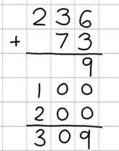

Year 3 Add numbers with up to 3-digits
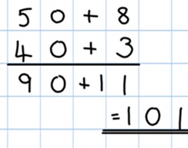
Continue to consolidate this method taught
in Year 2. Adding pairs of 2-digit numbers that cross
the tens boundary. (e.g. 58 + 43)



Introduce the expanded column addition method

In order to carry out this method of addition:

- Children need to recognise the value of the hundreds,
tens and ones without recording the partitioning.

- Pupils need to be able to add in columns.

The above methods will be taught alongside the use of Base 10 apparatus and place value counters so that children have practical and visual understanding of the values numbers being added.

Key vocabulary: add, more, plus, and, make, altogether, total, equal to, equals, double, most, count on, number line, sum, tens, ones, partition, plus, addition, column, tens boundary, hundreds boundary,
increase, vertical, ‗regroup, expanded,

Key skills for addition at Y3:
• Read and write numbers to 1000 in numerals and words.
• Add 2-digit numbers mentally, incl. those exceeding 100.
• Add a three-digit number and ones mentally (175 + 8)
• Add a three-digit number and tens mentally (249 + 50)
• Add a three-digit number and hundreds mentally (381 + 400)
• Estimate answers to calculations, using inverse to check answers.
• Solve problems, including missing number problems, using
• number facts, place value, and more complex addition.
• Recognise place value of each digit in 3-digit numbers (hundreds, tens, ones.)
• Continue to practice a wide range of mental addition strategies, ie. number bonds, adding the nearest
multiple of 10, 100, 100 and adjusting, using near doubles, partitioning and recombining.
Video clip: Demonstration of expanded 3 -digit column addition
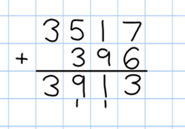


Year 4 Add numbers with up to 4 digits

Move from expanded addition to the compact column method, adding units
first, and ‘regrouping’ numbers underneath the calculation. Also include money and measures contexts.

e.g. 3517 + 396 = 3913

Introduce the compact column addition method by asking children to add the two given numbers together using the method that they are familiar
with (expanded column addition—see Y3). Teacher models the compact method with regrouping using place value counters and Base 10 apparatus until children are ready to move onto recording method. Children at this stage should have thorough understanding of place value and know multiplicative and additive values of 4-digit number

Add ones first.

Regroup numbers underneath the bottom line.

Reinforce correct place value by reminding them the actual value is 5 hundreds add 3 hundreds, not 5 add 3, for example.

Use and apply this method to money and measurement values.

Key vocabulary: add, more, plus, and, make, altogether, total, equal to, equals, double, most, count on, number line, sum, tens, ones, partition, plus, addition, column, tens boundary, hundreds boundary, increase, vertical, regroup expanded, compact, thousands, hundreds, digits, inverse

Key skills for addition at Y4:
• Select most appropriate method: mental, jottings or written and explain why.
• Recognise the place value of each digit in a four-digit number.
• Round any number to the nearest 10, 100 or 1000.
• Estimate and use inverse operations to check answers.
• Solve 2-step problems in context, deciding which operations and methods to use and why.
• Find 1000 more or less than a given number.
• Continue to practice a wide range of mental addition strategies, ie. number bonds, add the nearest multiple of 10, 100, 1000 and adjust, use near doubles, partitioning and recombining.
• Add numbers with up to 4 digits using the formal written method of column addition
• Solve 2-step problems in contexts, deciding which operations and methods to use and why.
• Estimate and use inverse operations to check answers to a calculation.


Year 5 Add numbers with more than 4 digits

Including money, measures and decimals with different numbers of decimal places.

The decimal point should be aligned in the same
way as the other place value columns and must be in the same column in the answer.

 Numbers should exceed 4 digits.

Pupils should be able to add more than two values, carefully aligning place value columns.

Say “6 tenths add 7 tenths’ to
reinforce place value.
Empty decimal places can be
filled with zero to show the place value in each column.
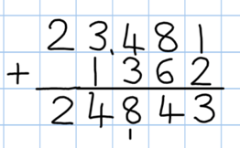
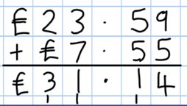
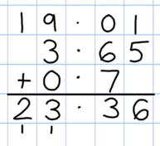

Children should:

• Understand the place value of tenths and hundredths and use this to align numbers with different numbers of decimal places.

Key vocabulary: add, more, plus, and, make, altogether, total, equal to, equals, double, most, count on, number line, sum, tens, ones, partition, plus, addition, column, tens boundary, hundreds boundary, increase, regroup, expanded, compact, vertical, thousands, hundreds, digits, inverse & decimal places, decimal point, tenths, hundredths, thousandths

Key skills for addition at Y5:
• Add numbers mentally with increasingly large numbers, using and practising a range of mental strategies ie. add the nearest multiple of 10, 100, 100 and adjust; use near doubles, inverse, partitioning and
re-combining; using number bonds.
• Use rounding to check answers and accuracy.
• Solve multi-step problems in contexts, deciding which operations and methods to use and why.
• Read, write, order and compare numbers to at least 1 million and determine the value of each digit.
• Round any number up to 1 000 000 to the nearest 10, 100, 1000, 10 000 and 100 000.
• Add numbers with more than 4 digits using formal written method of columnar addition.
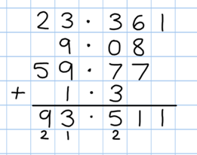
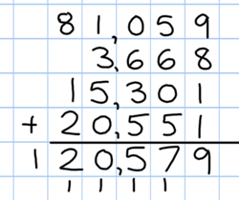

Year 6 Add several numbers of increasing complexity

Adding several numbers with different numbers of decimal places (including money and measures):

• Tenths, hundredths and thousandths should be correctly aligned, with the decimal point lined up vertically including in the answer row.


• Zeros could be added into any empty decimal places, to show there is no value to add.

Empty decimal places can be filled with zero to show the place value in each column.

Adding several numbers with more than 4 digits starting
with the ones column.

Key vocabulary: add, more, plus, and, make, altogether, total, equal to, equals, double, most, count on, number line, sum, tens, units, partition, plus, addition, column, tens boundary, hundreds boundary,
increase, regroup expanded, compact, vertical, thousands, hundreds, digits, inverse, decimal places, decimal point, tenths, hundredths, thousandths

Key skills for addition at Y6:
• Perform mental calculations, including with mixed operations and large numbers, using and practising a range of mental strategies.
• Solve multi-step problems in context, deciding which operations and methods to use and why.
• Use estimation to check answers to calculations and determine, in the context of a problem, levels of accuracy.
• Read, write, order and compare numbers up to 10 million and determine the value of each digit.
• Round any whole number to a required degree of accuracy.
• Pupils understand how to add mentally with larger numbers and calculations of increasing complexity.
- Recognise and use the inverse relationship between addition and subtraction and use this to check calculations and missing number problems.
- Pupils use their knowledge of operations to carry out calculations involving the 4 operations and using brackets for example (2 + 1) x 3 = 9



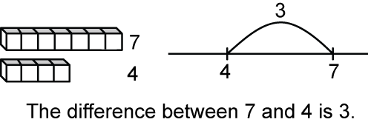
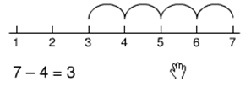

Year 1 Subtract from numbers up to 20

Children consolidate understanding of subtraction practically,
showing subtraction on bead strings, using cubes etc. and in familiar contexts, and are introduced to more formal recording using number lines as below:

Subtract by taking away

Read, write and interpret number sentences with
- and = signs.

Count back in ones on a numbered number line to take away, with numbers up to 20:

Find the “distance between”
-1 -1 -1 -1

Model subtraction using hundred squares and numbered number lines/tracks and practically.

This will be introduced
practically with the language “find the distance between” and
“how many more?” in a
range of familiar contexts.

“Seven is 3 more than four‟

“I am 2 years older than my sister”

Mental subtraction

Children should start recalling subtraction facts up to and within 10 and 20, and should be able to subtract zero.

Key vocabulary: equal to, take, take away, less, minus, subtract, leaves, distance between, how
many more, how many fewer / less than, most, least, count back , how many left, how much less is_?

Key skills for subtraction at Y1:
• Given a number, say one more or one less.
• Count to and over 100, forward and back, from any number.
• Represent and use subtraction facts to 20 and within 20.
• Subtract with one-digit and two-digit numbers to 20, including zero.
• Solve one-step problems that involve addition and subtraction, using concrete objects (ie bead string, objects, cubes) and pictures, and missing number problems.
• Read and write numbers from 0 to 20 in numerals and words.
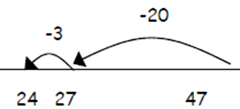
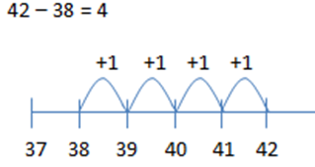
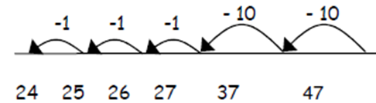
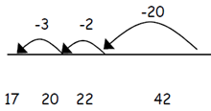


Year 2 Subtract with 2-digit numbers

Subtract on a number line by counting back, aiming to develop
mental subtraction skills.

This strategy will be used for:

Use Base 10 blocks for - calculations too.

• 2-digit numbers subtract ones (by taking away / counting back) e.g. 36—7
• 2-digit numbers subtract tens (by taking away / counting back) e.g. 48—30
• Subtracting pairs of 2-digit numbers (see below:)

Subtracting pairs of 2-digit numbers on a number line:

47 - 23 = 24 Partition the second number and subtract it in tens and one, as below:

Move towards more efficient jumps back, as below:

Then subtract ones.

Subtract tens first.

Combine methods with use of a hundred square to reinforce understanding of
number value and order.

Teaching children to bridge through ten
can help them to become more efficient, for example 42—25:

Mental strategy - subtract numbers close together by counting on:

Start with the smaller number and count on to
the largest.

Many mental strategies are taught. Children are taught to recognise that when numbers are close together, it is more efficient to count on the difference. They need to be clear about the relationship between addition and subtraction.

Key vocabulary: equal to, take, take away, less, minus, subtract, leaves, distance between, how
many more, how many fewer / less than, most, least, count back , how many left, how much less is_?
difference, count on, strategy, partition, tens, ones
Key skills for subtraction at Y2:
• Recognise the place value of each digit in a two-digit number.
• Recall and use subtraction facts to 20 fluently, and derive and use related facts up to 100.
• Subtract using concrete objects, pictorial representations, 100 squares and mentally, including: a two- digit number and ones, a two-digit number and tens, and two two-digit numbers.
• Show that subtraction of one number from another cannot be done in any order.
• Recognise and use inverse relationship between addition and subtraction, using this to check calcula- tions and missing number problems.
• Solve simple addition and subtraction problems including measures, using concrete objects, pictorial
representation, and also applying their increasing knowledge of mental and written methods.
• Read and write numbers to at least 100 in numerals and in words.
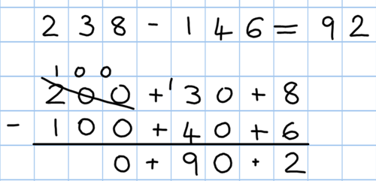
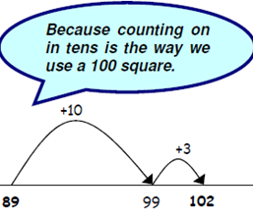
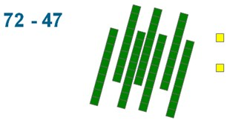
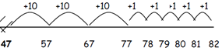


Year 3 Subtracting with 2 and 3-digit numbers.
Continue to hop on along number line before introducing partitioned column.

STEP 1: introduce this method with examples where no regrouping is required.

89 - 35 = 54

80 + 9
- 30 + 5
50 + 4
When learning to regroup, explore
„partitioning in different ways‟ so that pupils understand that when you regroup, the VALUE is the same ie 72 = 70+2 = 60+12 = 50+22 etc. Emphasise that the value hasn‘t changed, we have just partitioned it in a different way.

STEP 2: Introduce regrouping through practical subtraction. Make the larger number with Base
10 or place value counters, then subtract 47 from
it

Before subtracting ‘7’ from the 72 blocks, they will need to exchange a row of 10 for ten ones. Then subtract 7, and subtract 4 tens.

STEP 3: Once pupils are secure with the understanding of
‟regrouping’, they can use the
partitioned column method to subtract any 2 and 3-digit numbers.

Subtracting money:
partition into e.g.
£1 + 30p + 8p

Counting on as a mental strategy for subtraction:

Continue to reinforce counting on as a strategy for close-together numbers (e.g. 121—118), and also for numbers that are ‟nearly‟ multiples of 10, 100, 1000 or £s, which make it easier to count on (e.g. 102-89, 131—79, or calculating change from £1 etc.).
• Start at the smaller number and count on in tens first, then count on in ones to find the rest of the difference:

Key vocabulary: equal to, take, take away, less, minus, subtract, leaves, distance between, how many more, how many fewer / less than, most, least, count back , how many left, how much less is_? difference, count on, strategy, partition, tens, ones regroup, decrease, hundreds, value, digit
Key skills for subtraction at Y3:
• Subtract mentally a: 3-digit number and ones, 3-digit number and tens, 3-digit number and hundreds .
• Estimate answers and use inverse operations to check.
• Solve problems, including missing number problems.
• Find 10 or 100 more or less than a given number.
• Recognise the place value of each digit in a 3-digit number .
• Counting up differences as a mental strategy when numbers are close together or near
multiples of 10 (see examples above)
• Read and write numbers up to 1000 in numerals and words.

• Practise mental subtraction strategies, such as subtracting near multiples of 10 and adjusting (e.g. subtracting 19 or
21), and select most appropriate methods to subtract, explaining why.
Video clips: 1—Subtraction—teaching children to consider the most appropriate methods before calculating
2—Introducing partitioned column subtraction method, from practical to written

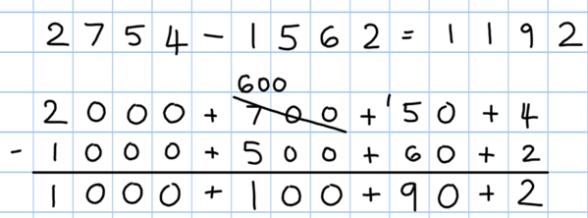
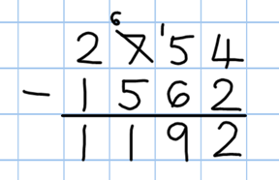


Year 4 Subtract with up to 4-digit numbers

Partitioned column subtraction with regrouping (decomposition):

As introduced in Y3, but moving towards more complex numbers and values. Use place value counters to reinforce
regrouping

Compact column subtraction (see video)
Subtracting money: partition
into £1 + 30 + 5 for example

To introduce the compact method, ask children to perform a subtraction calculation with the familiar partitioned column subtraction then display the compact version for the calculation they have done. Ask pupils to consider how it relates to the method they know, what is similar and what is different, to develop an understanding of it (shown on video).

Give plenty of opportunities to apply this to money and measures.

Mental strategies

Always encourage children to consider the best method for the numbers involved— mental, counting on, counting back or writ- ten method (see video).

A variety of mental strategies must be taught and practiced, including counting on to find
the difference where numbers are closer together, or where it is easier to
count on (see video below).

Key vocabulary: equal to, take, take away, less, minus, subtract, leaves, distance between, how many more, how many fewer / less than, most, least, count back , how many left, how much less is_? difference,
count on, strategy, partition, tens, ones, exchange, decrease, hundreds, value, digit,
inverse
Key skills for subtraction at Y4:
• Subtract by counting on where numbers are close together or they are near to multiples of 10, 100 etc.
• Children select the most appropriate and efficient methods for given subtraction calculations.
• Estimate and use inverse operations to check answers.
• Solve addition and subtraction 2-step problems, choosing which operations and methods to use and why.
• Solve simple measure and money problems involving fractions and decimals to two decimal places.
• Find 1000 more or less than a given number.
• Count backwards through zero, including negative numbers.
• Recognise place value of each digit in a 4-digit number Round any number to the nearest 10, 100 or 1000
• Solve number and practical problems that involve the above, with increasingly large positive numbers.
Videos: 1—Subtraction—teaching children to consider the most appropriate methods before calculating
2—Introducing partitioned column subtraction method, from practical to written
3—Moving to the compact column method of subtraction
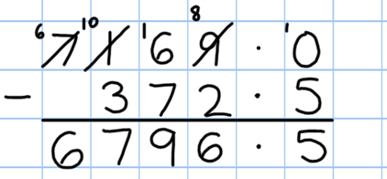
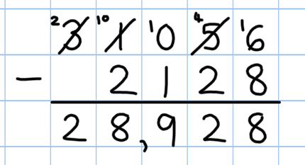


Year 5 Subtract with at least 4-digit numbers

including money, measures, decimals.

Compact column subtraction

(with “regrouping”).

Children who are still not secure with number facts and place value will need to remain on the partitioned column method until ready
for the compact method.

Subtracting with larger integers.

Subtract with decimal values, including mixtures
of integers and decimals, aligning the decimal point.

Create lots of opportunities for subtracting and finding differences with money and measures.

Add zero in empty decimal places to aid understanding of what to subtract in that column.

Key vocabulary: equal to, take, take away, less, minus, subtract, leaves, distance between, how many more, how many fewer / less than, most, least, count back , how many left, how much less is_? difference, count on, strategy, partition, tens, ones,
regroup, decrease, hundreds, value, digit, inverse, tenths, hundredths, decimal point, decimal

Key skills for subtraction at Y5:
• Subtract numbers mentally with increasingly large numbers .
• Use rounding and estimation to check answers to calculations and determine, in a range of contexts, levels of accuracy .
• Solve addition and subtraction multi-step problems in context, deciding which operations and methods
to use and why.
• Read, write, order and compare numbers to at least 1 million and determine the value of each digit.
• Count forwards or backwards in steps of powers of 10 for any given number up to 1 million.
• Interpret negative numbers in context, counting forwards and backwards with positive and negative in- tegers through 0.
• Round any number up to 1 million to the nearest 10, 100, 1000, 10 000 and 100 000.
Video clip:
Moving to the compact column method of subtraction
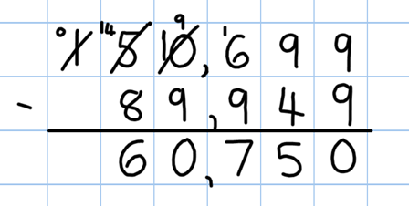
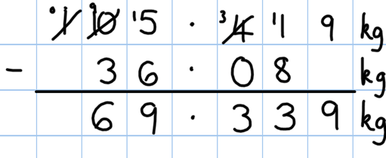


Year 6 Subtracting with increasingly large and more complex numbers and decimal values.

Using the compact column
method to subtract more complex integers

Using the compact column method to subtract money and measures, including decimals with different
numbers of decimal places.

Empty decimal places can be
filled with zero to show the place value in each column.

Pupils should be able to apply their knowledge of a range of mental strategies,
mental recall skills, and informal and formal written methods when selecting the most appropriate method to work out subtraction problems.

Key vocabulary: equal to, take, take away, less, minus, subtract, leaves, distance, between, how many more, how many fewer / less than, most, least, count back, How many left? How much left? How much is less? Difference, count on, strategy, partition, tens, ones, regroup,
decrease, hundreds, value, digit, inverse, tenths, hundredths, decimal point, decimal
Key skills for subtraction at Y6:
• Solve addition and subtraction multi-step problems in context, deciding which operations and methods to use and why.
• Read, write, order and compare numbers up to 10 million and determine the value of each digit
• Round any whole number to a required degree of accuracy
• Use negative numbers in context, and calculate intervals
• across zero.
• Children need to utilise and consider a range of mental subtraction strategies, jottings and written methods before choosing how to calculate.

Video clip: Moving onto Compact Method Subtraction


Year 1 Multiply with concrete objects, arrays and
pictorial representations.

How many legs will 3 teddies have?
There are 3 sweets in one bag.
How many sweets are in 5 bags altogether?

2 + 2 + 2 = 6
3+3+3+3+3
= 15





• Give children experience of counting equal group of objects in 2s,
5s and 10s.

• Present practical problem solving activities involving counting equal sets or groups, as above.

Key vocabulary: groups of, lots of, times, array, altogether, multiply, count

Key skills for multiplication at Y1:

Count in multiples of 2, 5 and 10.
Solve one-step problems involving multiplication, by calculating the answer using concrete objects, pictorial representations and arrays with the support of the teacher.
Make connections between arrays, number patterns, and counting in twos, fives and tens. Begin to understand doubling using concrete objects and pictorial representations.
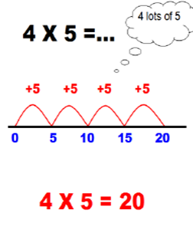
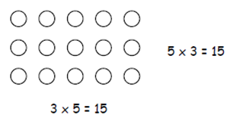
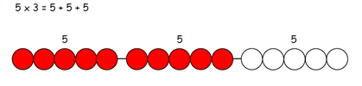




Year 2 Multiply using arrays and repeated addition
(using at least 2s, 5s and 10s)

Use repeated addition on a number line:

• Starting from zero, make equal jumps up on
a number line to work out multiplication facts and write multiplication statements using x and = signs.

#

Use arrays:

5 x 3 = 3 + 3 + 3 + 3 = 15

3 x 5 = 5 + 5 + 5 = 15

Use arrays to help teach children to understand the commutative law of
multiplication, and give examples such as 3 x = 6. The National Numeracy Strategy ITP ‘Multiplication Facts’ allows this to be modelled clearly.

Use practical apparatus:

Use mental recall:

• Children should begin to recall multiplication facts for 2, 5 and 10 times tables through practice in counting and understanding of the operation.

Key vocabulary: groups of, lots of, times, array, altogether, multiply, count, multiplied by, repeated addition, column, row, commutative, sets of, equal groups, times as big as, once, twice, three times...
Key skills for multiplication at Y2:
• Count in steps of 2, 3 and 5 from zero, and in 10s from any number.
• Recall and use multiplication facts from the 2, 5 and 10 multiplication tables, including recognising odds and evens.
• Write and calculate number statements using the x and = signs.
• Show that multiplication can be done in any order (commutative).
• Solve a range of problems involving multiplication, using concrete objects, arrays, repeated addition, mental methods, and multiplication facts.
• Pupils use a variety of language to discuss and describe multiplication.

Video clips:
Teaching for understanding of multiplication facts
Practical multiplication and the commutative law
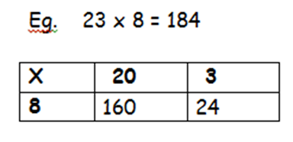
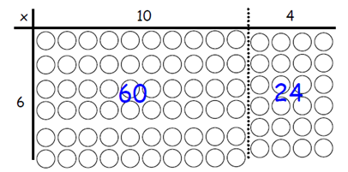
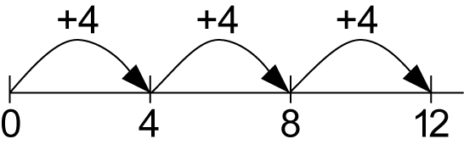
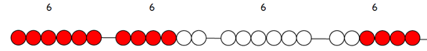
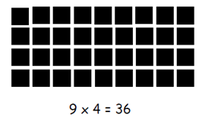



Year 3 Multiply 2-digits by a single digit number

Introduce the grid method for multiplying 2-digit by single-digits:

Link the layout of the grid to an array initially:

160 + 24 = 184

Introduce the grid method with children physically making an array to represent the calculation (e.g. make 8 lots of 23 with 10s and 1s place value counters), then translate this to grid method format (see video clip). The National Numeracy Strategy ITP ‘Multiplication Grid’ allows this to be modelled clearly.

To do this, children must be able to:

• Partition numbers into tens and ones
• Multiply multiples of ten by a single digit (e.g. 20 x 4) using their knowledge of multiplication facts and place value
• Recall and work out multiplication facts in the 2, 3, 4, 5, 8 and 10 times tables.
• Work out multiplication facts not known by repeated addition or other taught mental strategies (e.g. by commutative law, working out near multiples and adjust- ing, using doubling etc.) Strategies to support this are repeated addition using a
number line, bead bars and arrays:

Key vocabulary: groups of, lots of, times, array, altogether, multiply, count, multiplied by, repeated ad- dition, column, row, commutative, sets of, equal groups, times, _times as big as, once, twice, three times...,
partition, grid method, multiple, product, tens, ones, value
Key skills for multiplication:
• Recall and use multiplication facts for the 2, 3, 4, 5, 8 and 10 multiplication tables, and multiply multiples of 10.
• Write and calculate number statements using the multiplication tables they know, including 2-digit x single-digit, drawing upon mental methods, and progressing to reliable written methods.
• Solve multiplication problems, including missing number problems.
• Develop mental strategies using commutativity (e.g. 4 x 12 x 5 = 4 x 5 x 12 = 20 x 12 = 240)
• Solve simple problems in contexts, deciding which operations and methods to use.
• Develop efficient mental methods to solve a range of problems e.g using commutativity (4 × 12 × 5 =
4 × 5 × 12 = 20 × 12 = 240) and for missing number problems x 5 = 20, 3 x = 18, x = 32
Video clips: Teaching the grid method as an interim step (partitioning and counters to introduce grid)
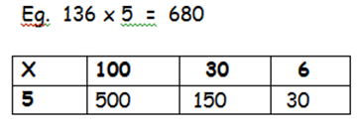


Year 4 Multiply 2 and 3-digits by a single digit, using
all multiplication tables up to 12 x 12

Developing the grid method:

500

150

+ 30

680

Encourage expanded column addition or compact column to add accurately depending on stage of fluency.

.

Children should be able to:


• Approximate before they calculate, and make this a regular part of their calculating, going back to the approximation to check the reasonableness of their answer. e.g:

346 x 9 is approximately 350 x 10 = 3500
Record an approximation to check the final answer against.

• Multiply multiples of ten and one hundred by a single-digit, using their multiplication table knowledge.

• Recall all times tables up to 12 x 12

Key vocabulary: groups of, lots of, times, array, altogether, multiply, count, multiplied by, repeated addition, array, column, row, commutative, groups of, sets of, lots of, equal groups, times, multiply, times
as big as, once, twice, three times... partition, grid method, total, multiple, product, sets of, inverse
Key skills for multiplication at Y4:
• Count in multiples of 6, 7, 9, 25 and 1000
• Recall multiplication facts for all multiplication tables up to 12 x 12.
• Recognise place value of digits in up to 4-digit numbers
• Use place value, known facts and derived facts to multiply mentally, e.g. multiply by 1, 10, 100, by 0, or to multiply 3 numbers.
• Use commutativity and other strategies mentally 3 x 6 = 6 x 3 , 2 x 6 x 5 = 10 x 6 , 39x7 = 30 x 7 + 9 x 7.
• Solve problems with increasingly complex multiplication in a range of contexts.
• Count in multiples of 6, 7, 9, 25 and 1000
• Recognise the place value of each digit in a four-digit number (thousands, hundreds, tens, and ones)


Year 5 Multiply up to 4-digits by 1 or 2 digits.

Grid method multiplication
Encourage compact column method to add if unable to mentally
E.g. 1200
+ 80
28
1308

x | 30 | 6
20 | 600 | 120
4 | 120 | 24



Pupils to use place value counters and Base 10 apparatus to reinforce
values of numbers within grid.

Move onto Expanded Column Method once secure.

Pupils could be asked to work out a given calculation using the grid and compare to expanded column. What are similarities? What are differences? Can you see where same numbers appear in both calculations?


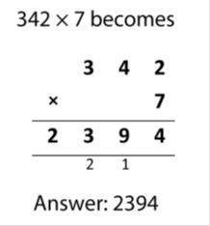

Key vocabulary groups of, lots of, times, array, altogether, multiply, count, multiplied by, repeated addition, column, row, commutative, sets of, equal groups, _times as big as, once, twice, three times..., partition, grid method, total, multiple, product, inverse, square, factor, integer, decimal, short/long multiplication, ‘carry’
Key skills for multiplication at Y5:
Identify multiples and factors, using knowledge of multiplication tables to 12x12.
Solve problems where larger numbers are decomposed into their factors
Multiply and divide integers and decimals by 10, 100 and 1000
Recognise and use square and cube numbers and their notation
Solve problems involving combinations of operations, choosing and using calculations and methods appropriately.
Video clips:
Teaching the grid method as an interim step
Expanded column multiplication
Short compact column method

Introducing short compact column multiplication with integers and decimals up to 2 decimal places.

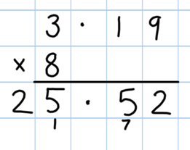

Year 6 Short and long multiplication as in Y5 using
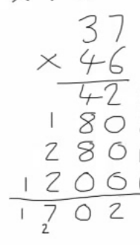
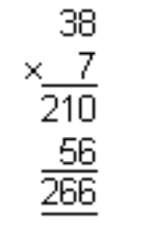
expanded column method.

Introducing short compact column multiplication
with integers and decimals up to 2 decimal places.

Long multiplication to multiply numbers with at least 4 digits
by a 2-digit number.


Key vocabulary: groups of, lots of, times, array, altogether, multiply, count, multiplied by, repeated addition, array, column, row, commutative, sets of, equal groups, times as big as, once, twice, three times...partition, grid method, total, multiple, product, inverse, square, factor, integer, decimal, short / long multiplication, regroup, tenths, hundredths, decimal
Key skills for multiplication at Y6:
• Recall multiplication facts for all times tables up to 12 x 12 (as Y4 and Y5).
• Multiply multi-digit numbers, up to 4-digit x 2-digit using long multiplication.
• Perform mental calculations with mixed operations and large numbers.
• Solve multi-step problems in a range of contexts, choosing appropriate combinations of operations and methods.
• Estimate answers using round and approximation and determine levels of accuracy.
• Round any integer to a required degree of accuracy.
Video clips:
Expanded column method multiplication Short compact column method Demonstration of long multiplication


Year 1 Group and share small quantities

Using objects, diagrams and pictorial representations to solve problems involving both grouping and sharing.

How many groups of 4 can be made with 12 stars? = 3

Grouping:

Sharing:

Pupils should :

Example division problem
in a familiar context:

There are 6 pupils on this table and there are 18 pieces of fruit to share between us. If we share them equally, how many will we each get?

Can they work it out and give
a division statement… ?

“18 shared between 6 people gives you 3 each.”

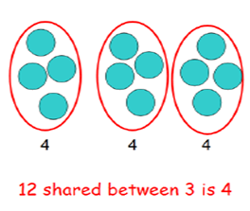

• use lots of practical apparatus, arrays and picture representations

• Be taught to understand the difference between “grouping‟ objects (How many groups of 2 can you make?) and “sharing‟ (Share these sweets between 2 people) The National Numeracy Strategy ITP ‘Grouping’ allows this to be modelled clearly.

• Be able to count in multiples of 2s, 5s and 10s.

• Find half of a group of objects by sharing into 2 equal groups.

Key Vocabulary: share, share equally, one each, two each…, group, groups of, lots of, array

Key number skills needed for division at Y1:
• Solve one-step problems involving multiplication and division, by calculating the answer using concrete objects, pictorial representations arrays with the support of the teacher
• Through grouping and sharing small quantities, pupils begin to understand, division, and finding
simple fractions of objects, numbers and quantities.
• They make connections between arrays, number patterns, and counting in twos, fives and tens.


Year 2 Group and share, using the ÷ and = sign
Use objects, arrays, diagrams and pictorial representations, and grouping on a number line.

Arrays:

This represents 12 ÷ 3, posed as
how many groups of 3 are in 12?

Pupils should also show that the same array can represent 12 ÷ 4 =
3 if grouped horizontally.

Know and understand sharing and grouping:


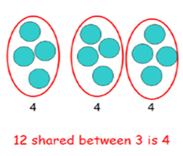

Children should be taught to recognise whether problems require sharing or grouping.

Grouping using a number line:
+3 +3 +3 +3
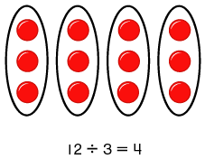
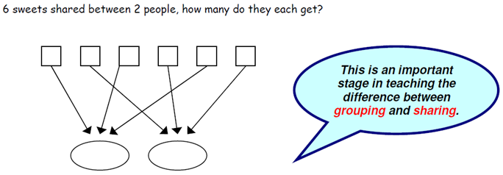
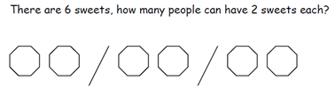
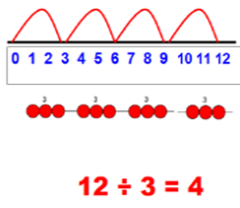

Group from zero in equal jumps of the divisor to find
out ‟how many groups of _ in _ ?‟. Pupils could be using a bead string or practical apparatus to work out problems like:
A CD costs £3. How many CDs can I buy with £12?‟ This is an important method to develop understanding of division as grouping. The National Numeracy Strategy ITP ‘Grouping’ allows this to be modelled clearly.

Pose 12 ÷ 3 as „How many groups of 3 are in 12?‟

Key Vocabulary: share, share equally, one each, two each…, group, equal groups of, lots of, array, divide, divided by, divided into, division, grouping, number line, left, left over
Key number skills needed for division at Y2:
• Count in steps of 2, 3, and 5 from 0
• Recall and use multiplication and division facts for the 2, 5 and 10 multiplication tables, including recognising odd and even numbers.
• Calculate mathematical statements for multiplication and division within the multiplication tables and write them using the x, ÷ and = signs.
• Show that multiplication of two numbers can be done in any order (commutative) and division of one
number by another cannot.
• Solve problems involving multiplication and division, using materials, arrays, repeated addition, mental methods, and multiplication and division facts, including problems in contexts.
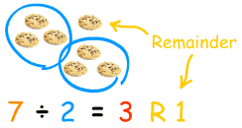
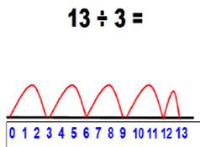



Year 3 Divide 2-digit numbers by a single digit
Revisit arrays from Year 2 prior to next step.

Grouping on a number line:
 |  |  | 4 r 1 | with no remainder and moving onto remainders, as shown in example. This should be introduced practically and with arrays, as well as
+3 | +3 | +3 | +3 r 1 | being translated to a number line. Children should work
 |  |  |  | towards calculating some basic division facts with remainders
 |  |  |  | mentally for the 2s, 3s, 4s, 5s, 8s and 10s.

STEP 1: Children continue to work out unknown division
facts by grouping on a number line from zero. Firstly,

Real life contexts need to be used routinely to help pupils gain a full understanding, and the ability to recognise the place of division and how to apply it to problems.

Arrays and grouping from Year 2, still supporting division as a concept.

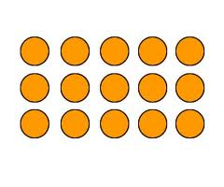

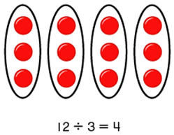

Key Vocabulary: share, share equally, one each, two each…, group, equal groups of, lots of, array, divide, divided by, divided into, division, grouping, number line, left, left over, inverse, short division, regroup, remainder, multiple
Key number skills needed for division at Y3:
• Recall and use multiplication and division facts for the 2, 3, 4, 5, 8 and 10 multiplication tables (through doubling, connect the 2, 4 and 8s).
• Write and calculate mathematical statements for multiplication and division using the multiplication tables that they know, including for two-digit numbers times one-digit numbers, using mental and progressing to for-
mal written methods.
• Solve problems, in contexts, and including missing number problems, involving multiplication and division.
• Pupils develop efficient mental methods, for example, using multiplication and division facts (e.g. using 3 × 2 =
6, 6 ÷ 3 = 2 and 2 = 6 ÷ 3) to derive related facts (30 × 2 = 60, so 60 ÷ 3 = 20 and 20 = 60 ÷ 3).
• Pupils develop reliable written methods for division, starting with calculations of 2-digit numbers by 1-digit numbers and progressing to the formal written method of short division.

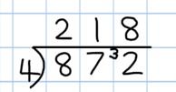
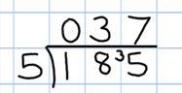
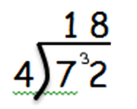


Year 4 Divide up to 3-digit numbers by a single digit
(without remainders initially)

Develop short division:
(‘Bus Stop’ or ‘Garage Door’ Method)

Short division should only be taught once children have secured the skill of
calculating “remainders‟.

STEP 1: Pupils must be secure with the process of
short division for dividing 2-digit numbers by a single digit (those that do not result in a final remainder)
but must understand how to calculate remainders, using this to regroup remainders within the calculation process (see example).

Real life contexts need to be used routinely to help pupils gain a full understand- ing, and the
ability to recognize the place of division and how to apply it to problems.
STEP 2: Pupils move onto dividing numbers with up
to 3-digits by a single digit, however problems and calculations provided should not result in a final answer with remainder at this stage.

When the answer for the first column is zero
When, for example, 1 divided by 5, children could initially write a zero above to acknowledge its place and must always regroup the number ‘1’ over next to the 8 as a remainder.
.

Key Vocabulary: share, share equally, one each, two each…, group, equal groups of, lots of, array, divide, divided by, divided into, division, grouping, number line, left, left over, inverse, short division, regroup
remainder, multiple, divisible by, factor
Key number skills needed for division at Y4:
• Recall multiplication and division facts for all numbers up to 12 x 12.
• Use place value, known and derived facts to multiply and divide mentally, including: multiplying and dividing by 10 and 100 and 1.
• Pupils practise to become fluent in the formal written method of short division with exact answers when
dividing by a one-digit number
• Pupils practise mental methods and extend this to three-digit numbers to derive facts, for example 200
× 3 = 600 so 600 ÷ 3 = 200
• Pupils solve two-step problems in contexts, choosing the appropriate operation, working with increasingly harder numbers. This should include correspondence questions such as three cakes shared equally
between 10 children.
Video Clip: of the bus stop method http://www.youtube.com/watch?v=58UQEp9AHE8
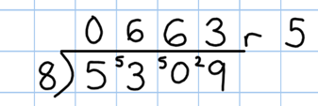


Year 5 Divide up to 4 digits by a single digit, including
those with remainders. (‘Bus Stop’ or ‘Garage Door’ Method)

Short division, including remainder answers:

The answer to 5309 ÷ 8 could be expressed as 663 and five eighths,
663 r 5, as a decimal, or rounded as appropriate to the problem involved.

Include money and measure contexts.
Short division with remainders: Now that pupils are introduced to examples that give rise to remainder answers, division needs to have a real life problem solving context, where pupils consider the meaning of the remainder and how to express it, ie. as a fraction, a decimal, or as a rounded number or value , depending upon the context of the problem.

See Y6 for how to continue the short division to give a decimal answer for children who are confident.

Key Vocabulary: share, share equally, one each, two each…, group, equal groups of, lots of, array,
divide, divided by, divided into, division, grouping, number line, left, left over, inverse, short division,
regroup, remainder, multiple, divisible by, factor, inverse, quotient, prime number, prime factors, composite number (non-prime)
Key number skills needed for division at Y5:
• Recall multiplication and division facts for all numbers up to 12 x 12 (as in Y4).
• Multiply and divide numbers mentally, drawing upon known facts.
• Identify multiples and factors, including finding all factor pairs of a number, and common factors of two number.
• Solve problems involving multiplication and division where larger numbers are decomposed into their factors.
• Multiply and divide whole numbers and those involving decimals by 10, 100 and 1000.
• Use the vocabulary of prime numbers, prime factors and composite (non-prime) numbers.
• Work out whether a number up to 100 is prime, and recall prime numbers to 19.
• Divide numbers up to 4 digits by a one-digit number using the formal written method of short division and inter- pret remainders appropriately for the context
• Use multiplication and division as inverses.
• Interpret non-integer answers to division by expressing results in different ways according to the context, includ- ing with remainders, as fractions, as decimals or by rounding (e.g. 98 ÷ 4 = 24 r 2 = 241/2 = 24.5 ≈ 25).
• Solve problems involving combinations of all four operations, including understanding of the equals sign, and includ-
ing division for scaling by different fractions and problems involving simple rates.

Video Clip: of the bus stop method expressing remainders as a decimal
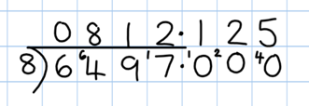
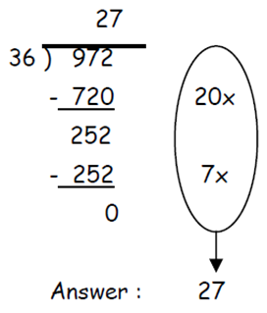

Year 6 Divide at least 4 digits by both single-digit and
2-digit numbers (including decimal numbers and quantities)

Short division, for dividing by a single digit: e.g. 6497 ÷ 8

Short division with remainders: Pupils should continue to use this method, but with numbers to at least 4 digits, and understand how to express remainders as fractions, decimals, whole number remainders, or rounded numbers. Real life problem solving contexts need to be the starting point, where pupils have to consider the most appropriate way to express the remainder.
Calculating a decimal remainder: In this example, rather than expressing the remainder as r 1, a decimal point is added after the units because there is still a remainder, and the one remainder is carried onto zeros after the decimal point (to show there was no decimal value in the original number).
Keep dividing to an appropriate degree of accuracy for the problem being solved.

Introduce long division by chunking for dividing by 2 digits.

• Find out „How many 36s are in 972?‟ by
Must be aligned in place value for subtract-ting.
subtracting „chunks‟ of 36, until zero is
reached (or until there is a remainder).
• Teach pupils to write a „useful list‘ first at
the side that will help them decide what chunks to use, e.g.:
‗Useful‘ list: 1x = 36
10x = 360
100x = 3600
Introduce the method in a simple way by limiting the choice of chunks to „can we use 10 lots? Can use 100 lots? As children become confident with the process, encourage more efficient chunks to get to the answer more quickly (e.g. 20x, 5x), and expand on their „useful‟ lists.

Where remainders
occur, pupils should express them as fractions, decimals or use rounding, depend- ing upon the problem.

,

Key Vocabulary: share, share equally, one each, two each…, group, equal groups of, lots of, array, divide, divided by, divided into, division, grouping, number line, left, left over, inverse, short division, regroup, remainder, multiple, divisible by, factor, inverse, quotient, prime number, prime factors, composite number (non-prime), common factor
Key number skills needed for division at Y6:
• Recall and use multiplication and division facts for all numbers to 12 x 12 for more complex calculations
• Divide numbers up to 4 digits by a two-digit whole number using the formal written method of long division, and interpret remainders as whole number remainders, fractions, or by rounding, as appropriate for the context. Use short division where appropriate.
• Perform mental calculations, including with mixed operations and large numbers.
• Identify common factors, common multiples and prime numbers.
• Solve problems involving all 4 operations.
• Use estimation to check answers to calculations and determine accuracy, in the context of a problem.
• Use written division methods in cases where the answer has up to two decimal places.
• Solve problems which require answers to be rounded to specified degrees of accuracy.

Video Clip: chunking (including remainders)

