Number and
Place Value

I can read Roman numerals to 100

Addition and Subtraction

Multiplication and
Division

Fractions

I can solve simple measure and money

Measures Geometry

Statistics

and understand how numerals changed.

I can solve number and practical problems using place value.

I can round any
I can solve mental calculations with increasingly large numbers.

I can solve subtraction 2-step problems, deciding
I can solve problems involving multiplying and dividing.

I can multiply
3-digit numbers by a 1-digit number.
problems involving fractions & decimals.

I can compare numbers with the same number
of decimal places.

I can round decimals
I can solve problems, converting hrs to mins, mins to secs, years
to months and weeks to days.

I can read, write and convert time
I can plot points and draw sides to complete a polygon.

I can translate shapes.
I use a range of scales when interpreting and presenting data.

I can solve ‘difference’ problems

number to the
nearest 10, 100
methods to use.
with 1 decimal place
to the nearest
between analogue
and digital clocks.

I can describe
using information
presented in charts.

or 1000.

I can solve addition 2-step
I can multiply
2-digit numbers by a 1-digit number.
whole number.

I can find the effect
position on a 2-D grid as co-ordinates

I can identify,
represent and estimate numbers.

I can order and compare numbers beyond 1000.

I can recognise the place value of each digit in a
4-digit number.

I can count backwards through
problems, deciding methods to use.

I can use inverses to check answers to calculations.

I can estimate to check answers
to calculations.

I can subtract

I can recognise
and use factor pairs in mental
calculations.

I can multiply 3 numbers
together.

I can use place value, known
and derived facts
to divide mentally.
of dividing a number by 10 & 100 and
identify the value of the digits in the answer.

I can recognise and write decimal equivalents to 1/4, 1/2 and 3/4.

I can recognise and
write decimal
equivalents of any number of 10ths or 100ths.

I can add and subtract fractions
I can estimate,
compare & calculate different measures including £ and p.

I can find the area of rectilinear shapes by counting
squares.

I can measure and calculate the perimeter of a rectilinear figure
in the first quadrant.

I can complete a simple symmetric
figure.

I can identify lines of symmetry in 2-D
shapes in different orientations.

I can compare and order angles up to 2 right angles by size.
I can solve ‘sum’
problems using information
presented in charts.

I can solve ‘comparison’ problems using information presented in charts.

I can interpret and present data using line graphs.

zero to include
negative numbers.

I can find 100 more or less than a given number.
numbers with up to
4 digits using
written methods.

I can add numbers with up to 4 digits

I can use place value, known and derived facts to multiply mentally.
with the same denominator.

I can identify, name and write equivalent fractions of a given
fractions.
in cm and m.

I can convert between different units of measure (e.g. km to m)

I can identify acute and obtuse
angles.

I can interpret and present data using bar charts.

I can count in multiples of 6, 7, 9,
25 and 1000.
using written methods.
I can recall x
and ÷ facts for multiplication tables up to 12x12.

I can count up and down in 100ths and recognise how 100ths arise.
I can compare &
classify geometric shapes based on properties & size.

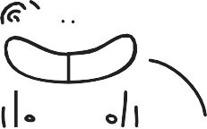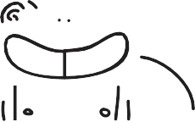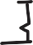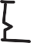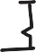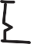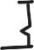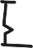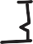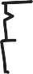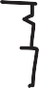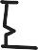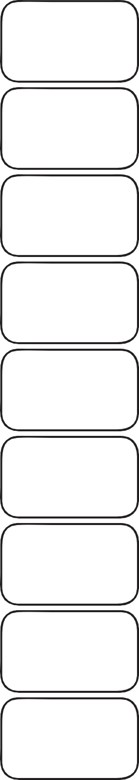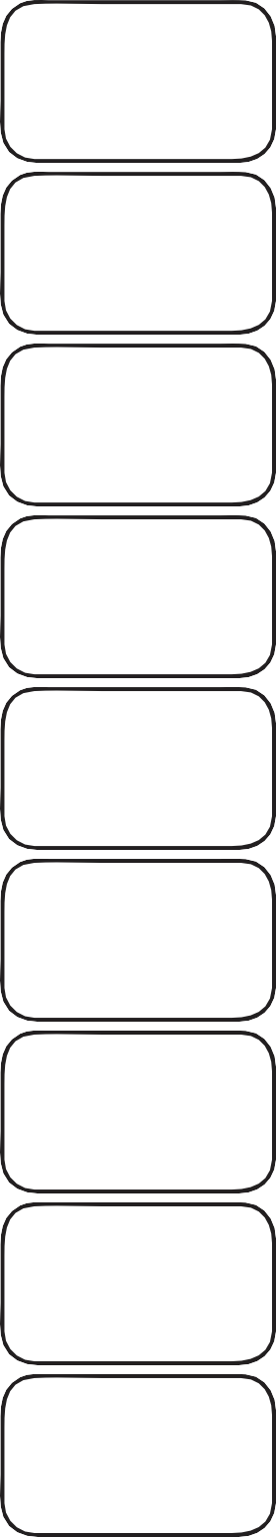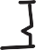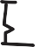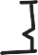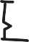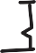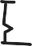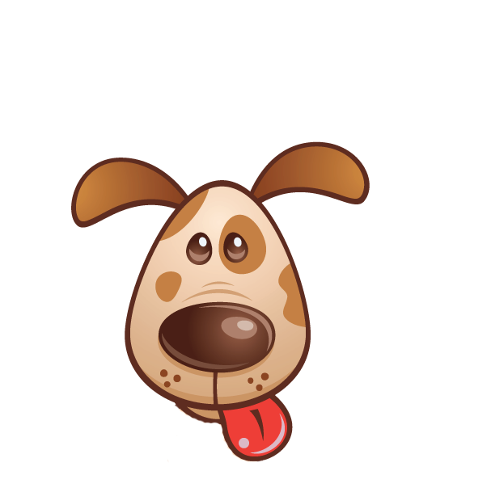

© Teacher’s Pet 2013 www.tpet.co.uk

