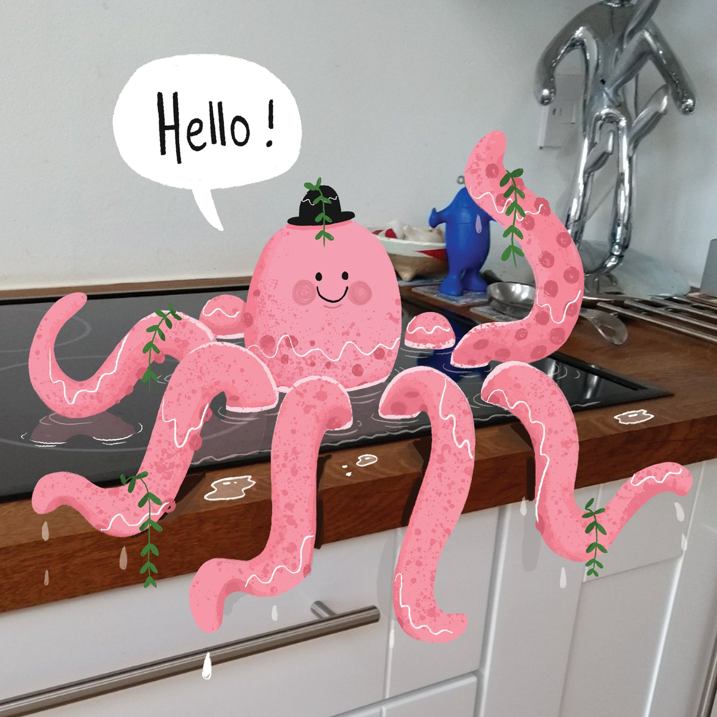
Ask your child what is happening in the picture. What character do you think he/she is? What is he/she is doing? Where is he/she? What do you think his/her name is? Who is he/she speaking to? Your child can verbally record their answers or write them down in sentences.

