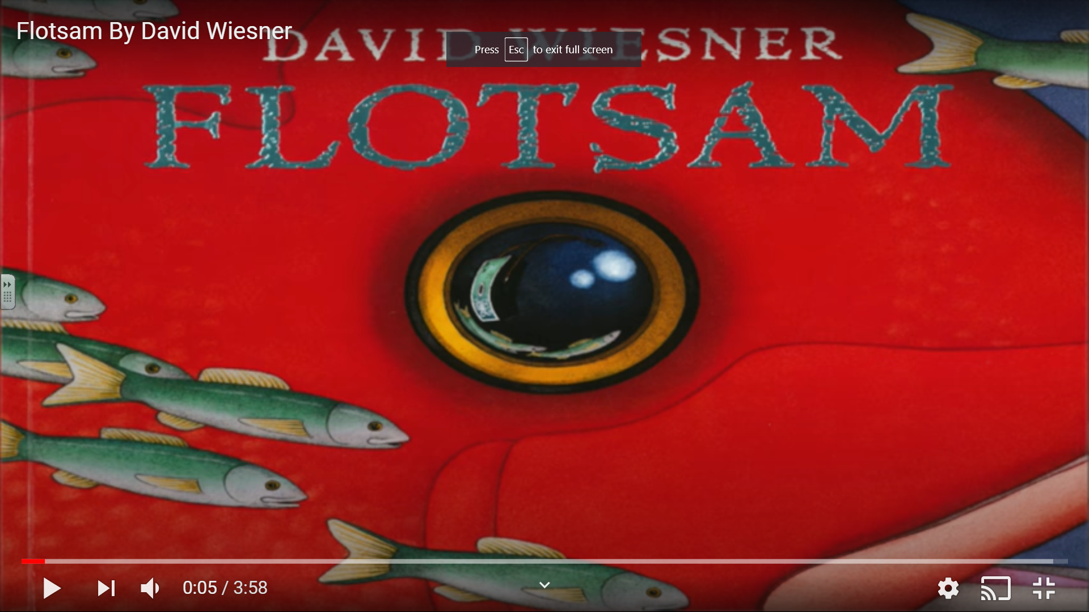
I can make a prediction about a text using the front cover.

