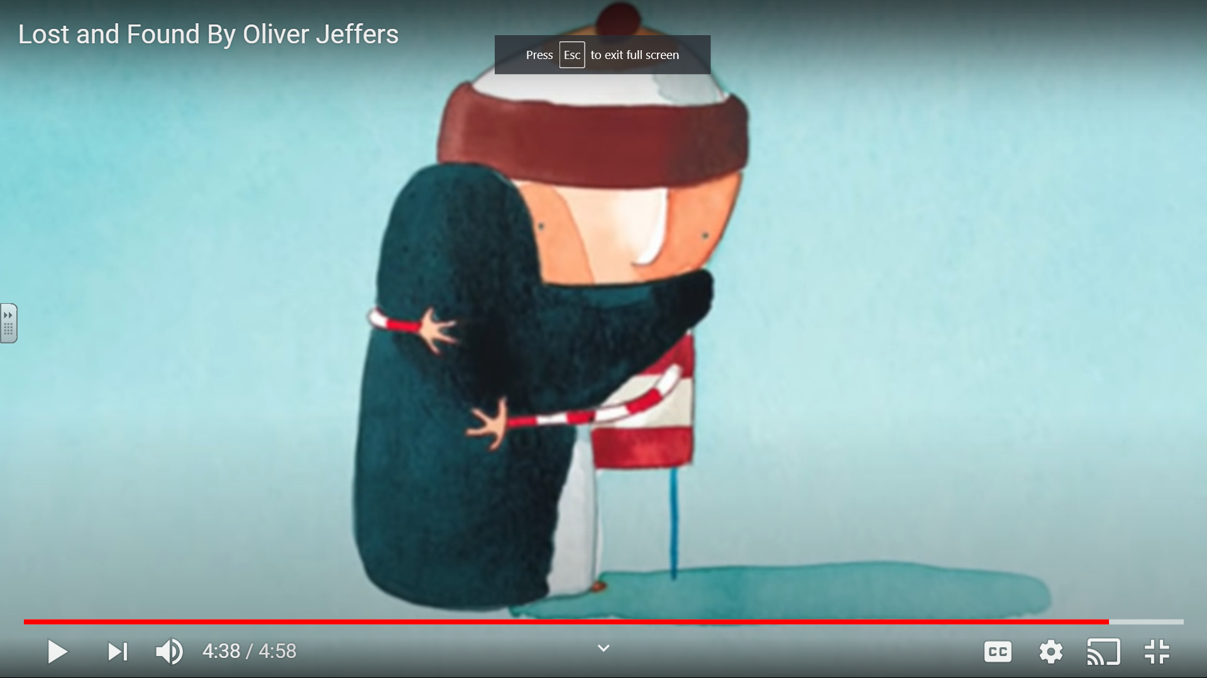
Look at this screen shot form the end of the story ‘Lost and Found’ How did they story end? Is it a happy ending? How do you think the penguin was feeling? How do you think the boy is feeling? Did their feelings change at the end of the story?
Can you retell the ending in your own words? Verbally or in senteces.

