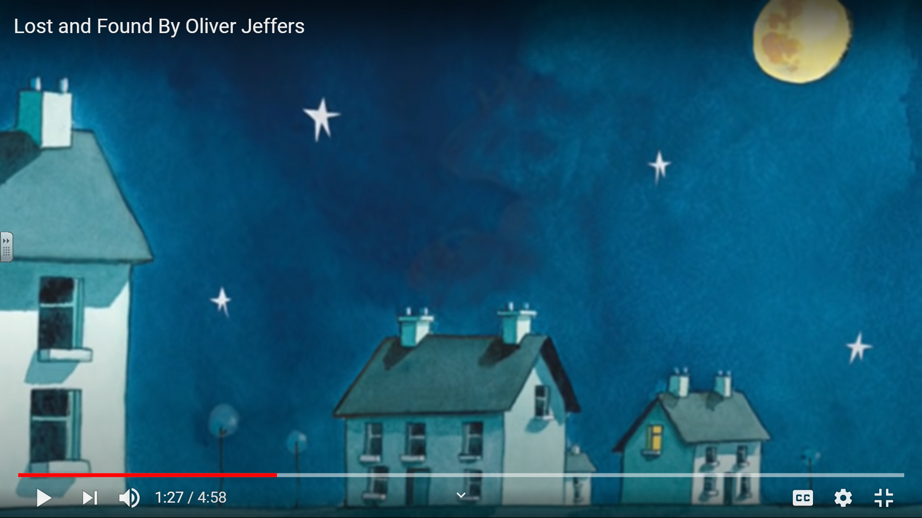
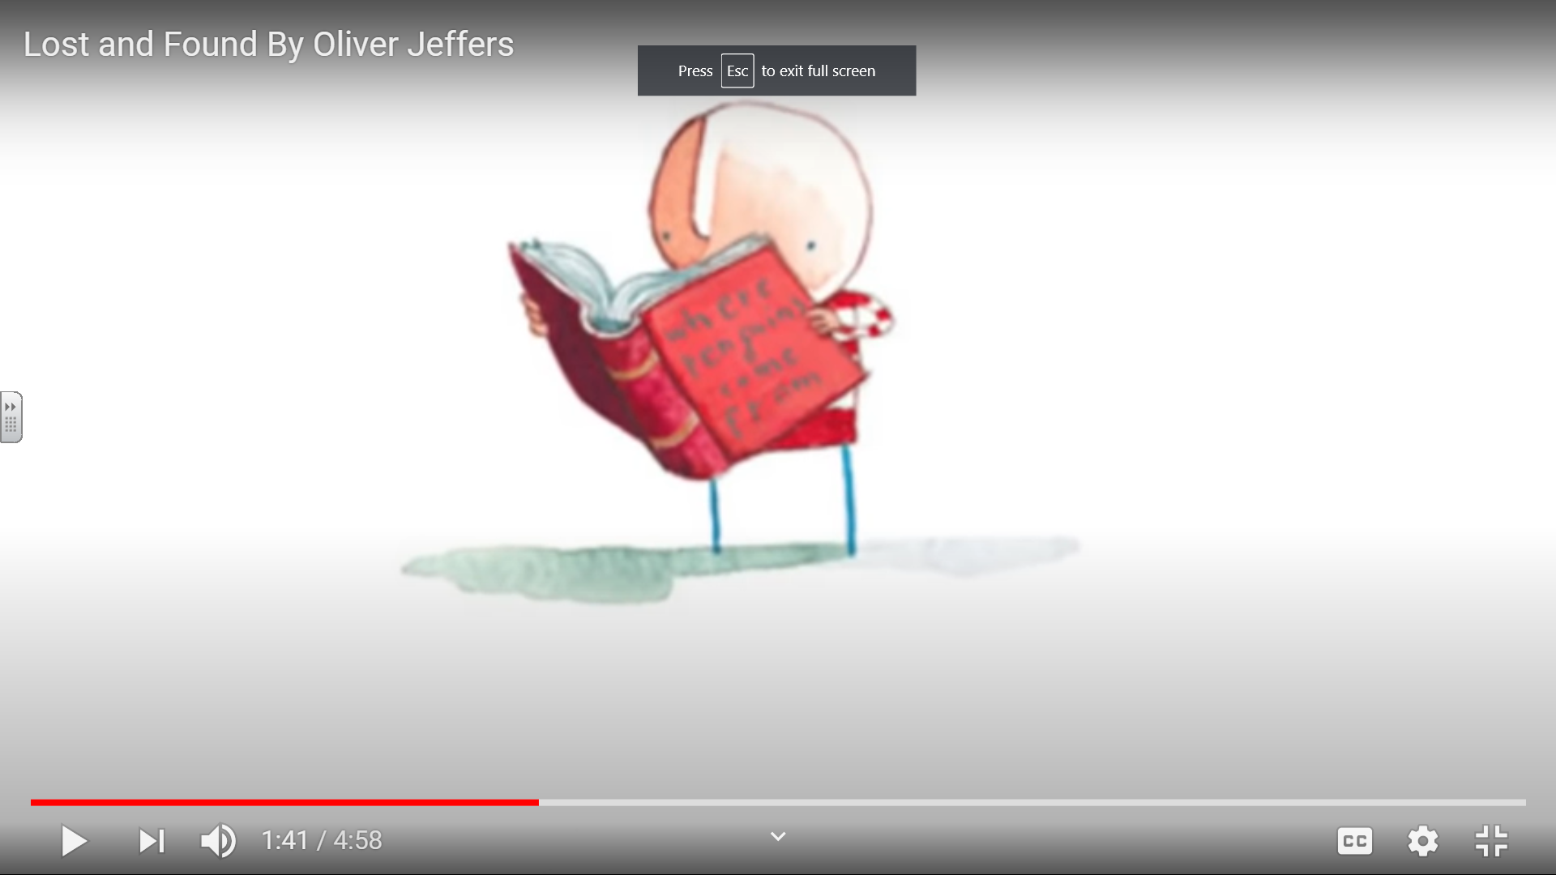
Talk about these two screen shots from The story ‘Lost and Found’ Is this from the beginning, middle or end? What is happening in this part of the story? Can you retell this part of the story to a grown up?
Write sentences to retell this part of the story. Remember Capital letters, full stops and your phonics skills when spelling.

