24 Acts for Easter 2020 KS1
  Find a Bible story that has an animal in it. Read it with an adult. | Bring something to school that can be given to a food bank.   | 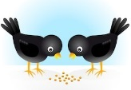  Make some food for the birds and put it out in your garden. | Find a toy or game at home that you don’t want anymore. Give it to a friend or to a charity shop.
  Make an extra journey than you normally would walking, cycling or scootering | Remember to say ‘thank you’ to God today for the food you eat, | 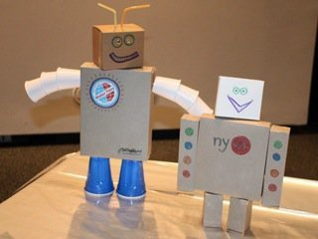  Make a model from recycled boxes or packets | 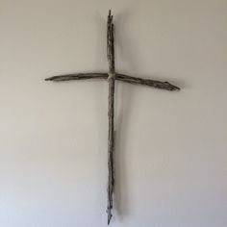  Find 2 twigs and a piece of string and make a cross.
  Enjoy playing with water today, but don’t waste it! When you’ve played in it use it to water some indoor plants. |   Look at a tree  maybe in a field or at home. Find out what tree it is. | Write a prayer where you say thank you God for this amazing world. It could begin with ‘Dear God…’ |   With an adult look at the sky at night (on a clear night). What can you see? Enjoy the beauty of the sky
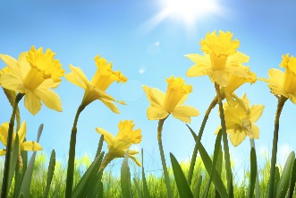  Look for some signs of spring today! | 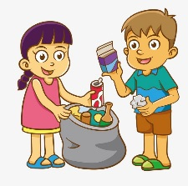Pick up litter that someone else has dropped and put it in the bin. | Take some time to be quiet outside Can you hear any birds or the wind blowing? |   Plant some seeds or bulbs.
  Eat all your lunch and say ‘thank you’ to whoever made it. | Count how many animals you see today. | Choose 1 day in the creation story. Make a picture that shows what Christians believe was created on that day. |   Help someone at home to sort out items for recycling.
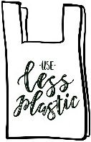  Make a poster to tell people to use less plastic | 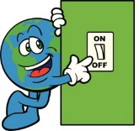  Make sure lights are turned off when no one is in a room. | 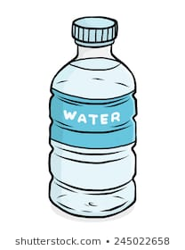  Go round your kitchen % count how many plastic bottles there are. Talk to an adult about how you could maybe buy less plastic next time you go shopping. | Decorate a real egg to have in your home over Easter  

