
AT ALL HALLOWS
CE PRIMARY SCHOOL
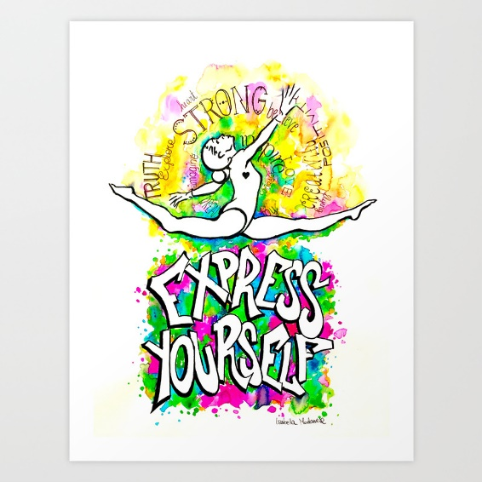
Welcome to FEEL GOOD FRIDAY! I hope that you are well and had an amazing week? I am so proud of you all!
If you watched our Wednesday assembly you will see that our theme is
EXPRESS YOURSELF!
As part of Children’s Mental Health Week, we have been celebrating YOU, and what makes you special.
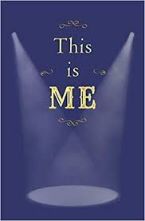
So your FEEL GOOD FRIDAY activity is to get a piece of paper and draw a colourful picture of yourself in the most amazing clothes. Around the outside of your picture write lots of words describing and celebrating yourself.
A PICTURE THAT SAYS, ‘THIS IS ME, AND I AM PROUD TO BE ME!’
OR, YOU COULD BE LIKE BANKSY, WHO WE LOOKED AT IN OUR WEDNESDAY ASSEMBLY AND USE THE FOLLOWING WALL TEMPLATE TO DO YOUR OWN PICTURE, OR EVEN DRAW YOUR OWN WALL! Please don’t graffiti on a wall, because I will get in trouble! HAVE FUN!
Please remember to email me your pictures!


