
Contestants

Bestwood (Foundation)
Mrs Gillett
Mrs Hally

Newstead (Y1)
Mrs Graham
Mrs Radford
Mrs Davey

Attenborough (Y2)
Mr Higgins
Mrs Sarno

Rufford (Y3)
Miss Doherty
Mrs McGill
Mrs Davis

Sherwood (Y4)
Mr Gillett
Mrs Somerville

Thoresby (Y5)
Mr Mulqueen
Mrs Hollingworth

Wollaton (Y6)
Mrs Baker
Miss Clark

Site Manager
Mr Brown

Head Teacher
Mr Graham

Write under each character which contestant you think it is.
Shrek  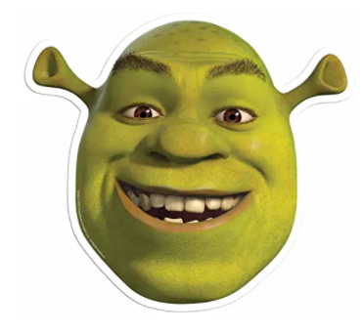 | Princess Fiona  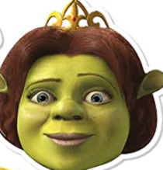 | Donkey  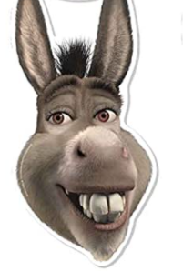 | Puss In Boots  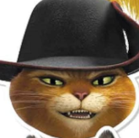 | Gingerbread Man  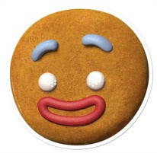 | Kylo Ren  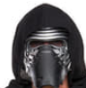
The Queen  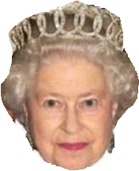 | Prince Charles  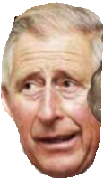 | Camilla  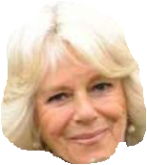 | Prince William  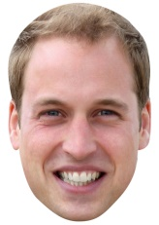 | Princess Kate  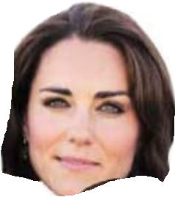 | Prince Harry  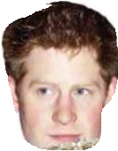
Kermit  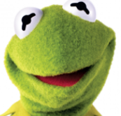 | Miss Piggy  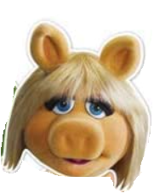 | Fozzy Bear  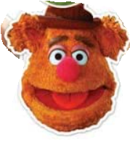 | Animal  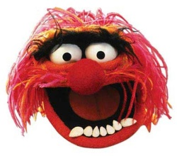 | Statler  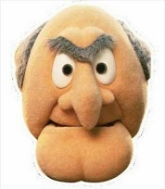 | Waldorf  

