

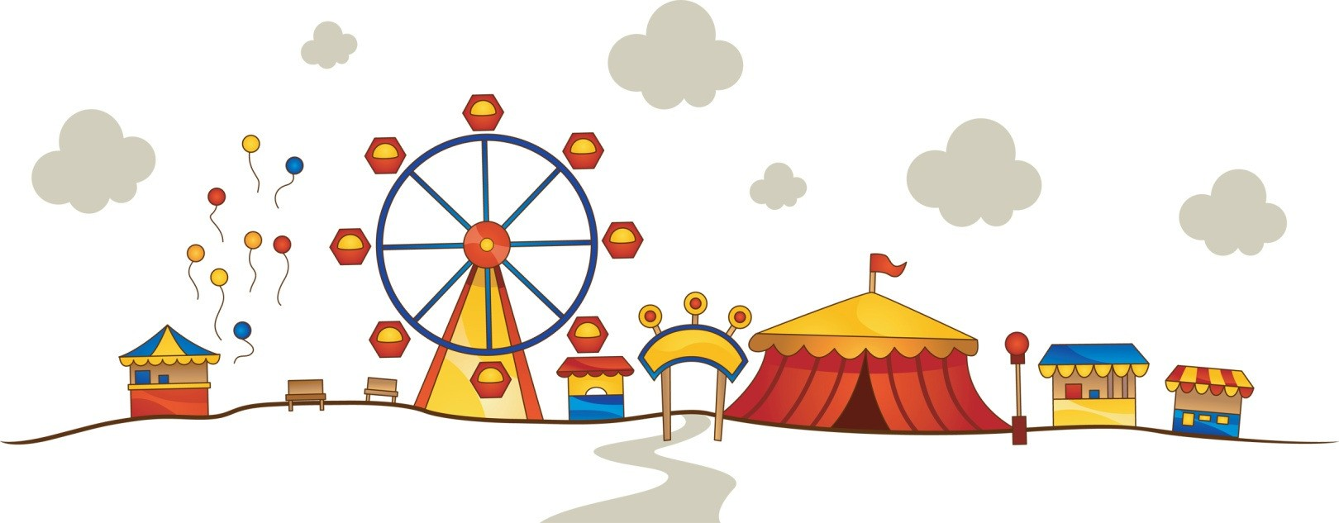

Welcome to Theme Park Maths, a unique investigation which sees you plan, build and operate a theme park. Your decisions throughout the investigation will be crucial as to whether you make a profit or a loss.

Good luck!





The scenario
A plot of land has become available and you have decided to build a brand new theme park.

You have managed to secure a £500 000 loan from the bank

During this activity you will have a range of tasks to complete, from building your theme park, to working out how much it costs to run and most importantly working out how much profit you can make

Task 1
Your first task is to plan your park. The piece of A3 square paper you will receive will be your park. (It the same as 2 pages from your maths book or jotter.) You must carefully decide what kind of rides you are going to have. You also need to think about the other facilities visitors will need when they come to your theme park. For example, toilets, cafes, shops and paths will all be available for purchase.

Many theme parks have different areas that are ‘themed’. Therefore you might like to have an African area, a wild west American area or a Space area. Think carefully about what you would like to include in yours and make your park the best in the UK.

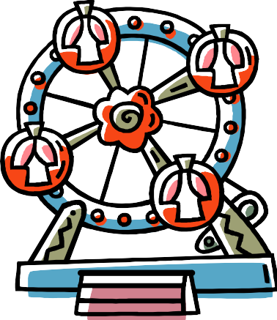



Task 1 – Setting up your theme park.
Your spending limit is £500 000. Design and draw your theme park on the squared paper. You must not go over your spending limit and you must have car parks, toilets, paths to connect all the items, cafes and shops for your visitors. It is not about just having rides. You will need to please all of your visitors

Each attraction comes under a different category. Each category varies in price. Choose carefully from the prices and information page, making sure you have something which appeals to everyone.

Follow the key below when colouring in the plan of your park.

Theme Park Key
Category 1 Rides: Red Category 2 Rides: Yellow Category 3 Facilities: Purple Bins: Orange
Toilets: Pink Trees: Green Lakes: Blue
Picnic Benches: Brown
Paths and Car Park: Grey

Prices
Category 1 Attractions - £50 000 each. These attractions take up 12cm²

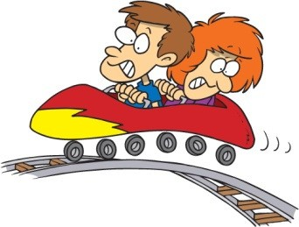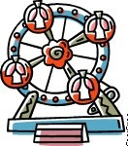
A rollercoaster A water ride A ferris wheel
Category 2 Attractions - £25 000 each. These attractions take up 6cm²

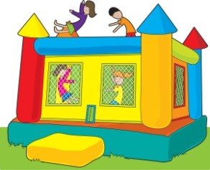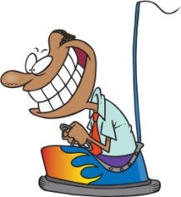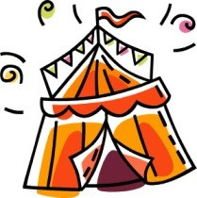
A bouncy castle Dodgems A Fun House

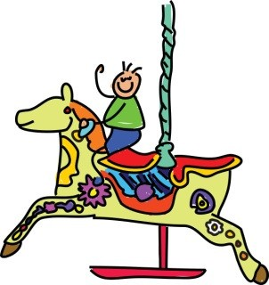
A haunted house Merry-go-round A Pirate Ship
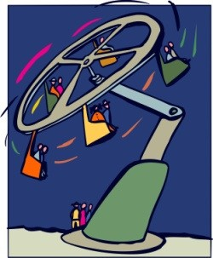 Circus Tent 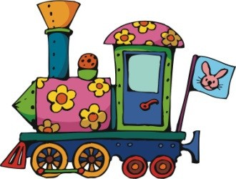 Spinning Ride Primary Teacher Resource Centre - 2011 Train
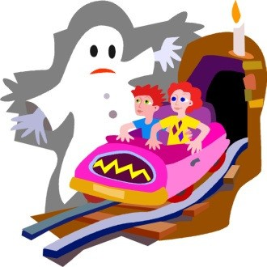
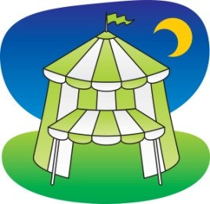

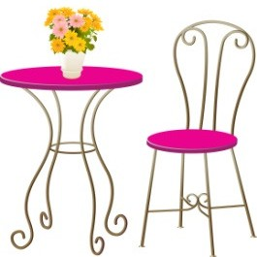
Category 3 Attractions - £8 000 each. These attractions take up 4cm²

A Cafe
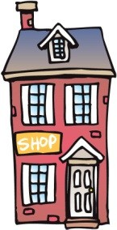

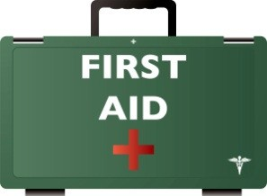
A Shop Ice Cream First Aid Centre

Other facilities and attractions – These items are individually price

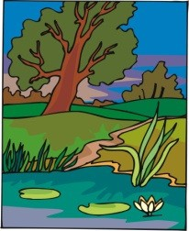

Path - £200 per 5cm length

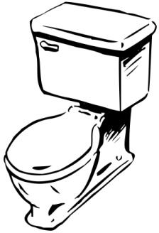
Toilets - £1 000.
4cm² per block of toilets

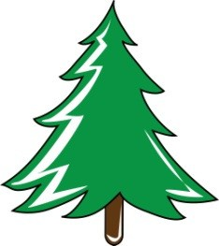
Tree - £200 per square (1 square per tree)

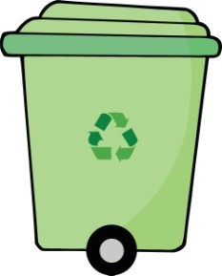
Rubbish Bin - £50 1cm² per bin
Lake - £1 000 per square

Car Park - £500 per square. Each square will take 100



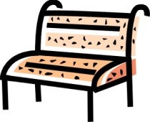
Picnic Benches - £100 per bench

Task 2: Running your theme park
To run your theme park the following costs will apply to each item that you have every day. How much will it cost to run your theme park for one day?

Complete the table above.

How much does it cost to open your park for one day? _

Further Activity
What about one week?

One year? _

Costs
Item | Staff  Costs | Electricity, Maintenance and  Repairs | Number in  park | Total Costs  per day
Category 1 Ride  (per ride) | £40 a day | £50 a day
Category 2 Ride  (per ride) | £30 a day | £30 a day
Category 3 Facility  (per facility) | £20 a day | £20 a day
Toilets  (for all toilets) | £5 a day | £5 a day | NA
Bins  (for all bins) | £31.50 a  week | £5.25 a week | NA
Trees  (for all trees) | £91.25 a  year | None | NA
 |  | Totals

Task 3 – Entry Fee
How much does it cost to open your park each day? (figure from task 2)

How many visitors do you think you will have each day? (remember it’s a brand new park and not many people know about it yet!)

Make an estimate: _

If you can, give your plan to someone else to look at, you must not tell them anything about your park. They must use the criteria below to decide your entry fee.

Price Category 1 - £20 per person.
- Four or more category 1 rides
- 10 or more rides in total
- 6+ category 3 facilities
- A first aid centre
- A well set out park with carefully placed bins, benches, toilets and paths.

Price Category 2 - £15 per person.
- Two or more category 1 rides
- 7 or more rides in total
- 4 or more category 3 facilities
- A first aid centre
- Some consideration to where bins, toilets, benches and paths are placed.

Price Category 3 - £10 per person
- One or more category 1 rides.
- 5 or more rides in total.
- 2 or more category 3 facilities.
- Some errors in where bins, toilets, benches and paths are placed which may lead to unhappy customers.

Price Category 4 - £5 per person
- At least 3 rides
- At least 1 category 3 facility.
- Some errors in where bins, toilets and paths are placed which may lead to unhappy customers.

Decide on the entry price and enter it here £ _

Task 4 – How much do you make on the entry fee?
Calculate how much you make each day based on the entry fee you set on the previous page.

Day | Number of  visitors | Income | Day | Number of  visitors | Income
1 | 50 |  | 16 | 89
2 | 75 |  | 17 | 104
3 | 66 |  | 18 | 130
4 | 49 |  | 19 | 209
5 | 61 |  | 20 | 143
6 | 67 |  | 21 | 99
7 | 102 |  | 22 | 111
8 | 110 |  | 23 | 206
9 | 87 |  | 24 | 350
10 | 21 |  | 25 | 300
11 | 24 |  | 26 | 278
12 | 67 |  | 27 | 453
13 | 66 |  | 28 | 294
14 | 98 |  | 29 | 367
15 | 109 |  | 30 | 359

Task 5 – Profit and Loss
Each visitor to your theme park will spend;

- £4 at each café you have
- £3 at each shop you have
- £1 at every ice cream stand you have

Work out your total profit from the admission price (gate), cafes and shops. Now take away your total costs that you have already worked out and find your profit or loss for each day.

Day | Number of visitors | Income |  |  |  |  | Total Costs (b)  (Task 2) | Profit (a-b)
Day | Number of visitors | Admission  (Task 4) | Café | Shop | Ice  Cream | Total (a) | Total Costs (b)  (Task 2) | Profit (a-b)
1 | 50
2 | 75
3 | 66
4 | 49
5 | 61
6 | 67
7 | 102
8 | 110
9 | 87
10 | 21
11 | 24
12 | 67
13 | 66

14 | 98
15 | 109
16 | 89
17 | 104
18 | 130
19 | 209
20 | 143
21 | 99
22 | 111
23 | 206
24 | 350
25 | 300
26 | 278
27 | 453
28 | 294
29 | 367
30 | 359
 |  |  |  |  |  |  | Total
  What profit or loss have you made in the first month of opening your theme park?

