Writing – planning
Today you are going to be planning your writing based on La Luna.
Remember we are going to be writing the narrative and speech between the characters.

First, watch the full short film here (it is only 6 minutes) https://www.youtube.com/watch?v=bdJgYQURH9k

You need to decide which part of the film you are going to write about in your writing. You need to choose to write about either the beginning, middle and end.

- The beginning = the opening of the film when the three characters are in the boat and the little boy receives the gift (from the start of the film until 2 minutes in when the father puts up the ladder)

- The middle = starting from 2 minutes in when the little boy climbs the ladder up into the sky, he puts the anchor down in all the stars and the boat starts drifting up, all three characters are walking on the stars and they start cleaning the stars (up until 4 minutes and 24 seconds)

- The end = starting from 4 minutes 24 seconds into the film, the giant star lands and they try to move it, the father and the old man arguing, the little boy bursts the giant star and all of the smaller stars cascade out, up until the end of the short film

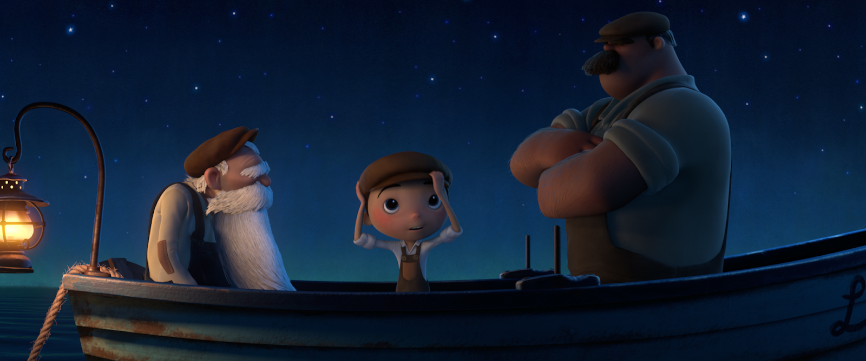
Task one: This is your plan for your writing. Add at least three words to the plan below. You are going to use this language in your writing so make sure you know the meaning of the words. We have added some examples to get you started.

I am going to be writing about the _______________________ part of La Luna when …

Purpose, audience, writing outcome and skill builder: | Skill builder: punctuating speech  Purpose: to entertain  Audience: Pixar (the film company)  Writing outcome: adding speech and narrative to La Luna
Ingredients | Vocabulary
synonyms for said | mumbled,
adverbs to describe the characters speech and movements | gingerly, cautiously,
adjectives to describe the old man | thoughtful,
adjectives to describe the boy | excited,
adjectives to describe the father | grumpy,
adjectives to describe the setting | tranquil,

Writing - drafting

- Read this WAGOLL (what a good one looks like). This is based on the middle section of the film.

The boy stared at the daunting sky and put his hand on the ladder. Trembling with fear, he took his first step.
“It’s okay, we will look after you, “said the father reassuringly. He slowly climbed up the ladder, towards the sky and he knew he was going to have adventure. When he reached the top of the ladder, he stood on the final rung with nowhere else to go. He started to float, dancing up towards the stars. He plonked down amongst an ocean of stars, taking in his surroundings.

The father and the old man joined the little boy. “Wow, what was that?” the little boy asked curiously as a star whooshed across the sky and landed near the boy. He jumped towards the star and whispered to himself, “What are you?”
“My young lad, come over here,” said the old man, his face lit up as if this were the first time he’d been here. The young boy scurried over, desperate to see what the old man and his father were doing.

Questions to think about:

- What works well in the WAGOLL?
- Are there any ideas you can magpie (borrow)?
- Is there any vocabulary you’d like to clarify and look up?

Now it is your turn to write.

Use your plan, the WAGOLL and the film clip to help you with your writing. You need to write at least 3 paragraphs (about half a page) and include at least 6 examples of speech. We can’t wait to read your writing!

