Tuesday Writing Task (skill builder)

1. Re-watch the trailer for La Luna https://www.youtube.com/watch?v=ZwlZCInKLfI

2. We are going to be adding speech to the short film La Luna and sending it to Pixar! You might have noticed that the characters don’t speak to each other using proper and full sentences (they tend to grunt at each other). So we are going to add speech to parts of the story.

3. What can you remember about speech? Can you open up your reading book and find examples of speech in there!

4. Watch these videos about speech marks:

https://www.youtube.com/watch?v=6-YFmLctwDY

https://www.bbc.co.uk/bitesize/topics/zvwwxnb/articles/ztcp97h

Now go through the attached PowerPoint all about speech.

Golden Rules about speech marks:

- When you are writing, inverted commas/speech marks go before and after direct speech, surrounding what was said.
"I'm hungry," she complained.
- If another character replies, use another set of inverted commas.
"What's for tea?" she asked.
"Delicious ants!" her mum replied.
- Punctuation, such as question marks, full stops and exclamation marks go inside the speech marks.
- New speaker = new line

Now you are going to complete four tasks about speech marks. Make sure you read each instruction carefully so you know what to do.

Task one: finding examples of speech

Let’s look at the different parts of speech. Using the highlight tool, highlight the different parts of the speech. We have done some for you as an example.

Speech
Reporting clause
Challenge: fronted adverbials
Three silhouettes drifted gently on the ocean, the waves gently lapping at the side of their boat. A small light guided them through the eternal darkness.
“WOW!” Exclaimed the little boy as he looked around.
“Put the anchor down, we are here,” grunted the father. Slowly, the old man heaved the anchor out of the boat and they watched it dance down until it hit the bottom of the ocean.
Full of excitement, the old man turned to get something out of his satchel and turned to face the boy, “Here you go my boy,” as he handed the boy a parcel. The little boys eyes lit up with excitement.

Task two: spot the mistake

Oh no! Can you correct the mistake in these sentences? Be careful - some of them are tricky!

- “I love being here with you, whispered the little boy.

- No! You wear it like this!” Shouted the old man as he readjusted the hat on the little boy.

- “Thank you for my hat, I look like you now” said the little boy who had a huge smile plastered on his face.

Task three: true or false

Are these statements about punctuating speech true or false? Write your answer in full sentences and give examples to prove your answer:

Statement | True or false?
Speech marks and inverted commas are different.
The reporting clause tells you who is speaking.
You start a new line when a new speaker starts speaking but not when speech is followed by the narrator.
You put speech marks round the speech and the reporting clause.
Reported speech and direct speech are different.

Task four: adding speech to the pictures
Look at these pictures from the trailer of La Luna. Add two sentences for each picture. At least one of your sentences should include speech which is punctuated correctly. Use the golden rules at the top of this document to help you.

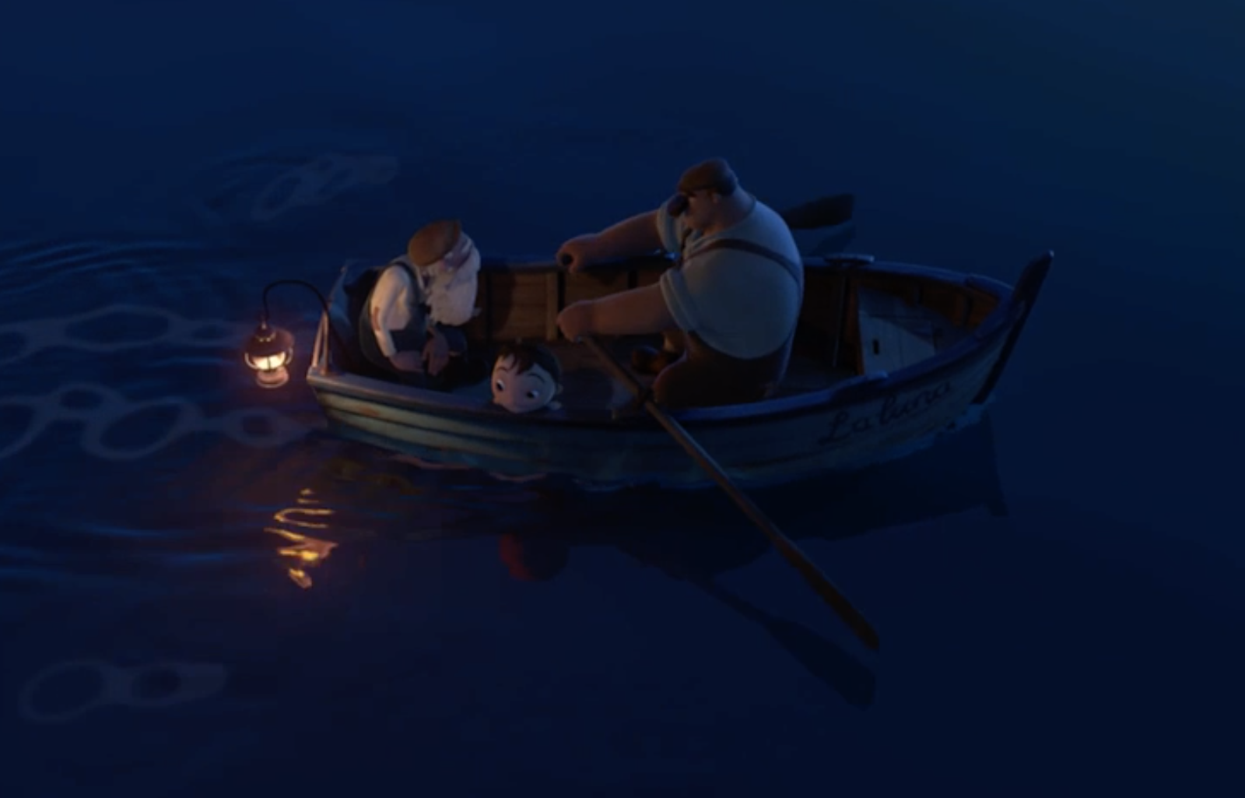

Your two sentences here:

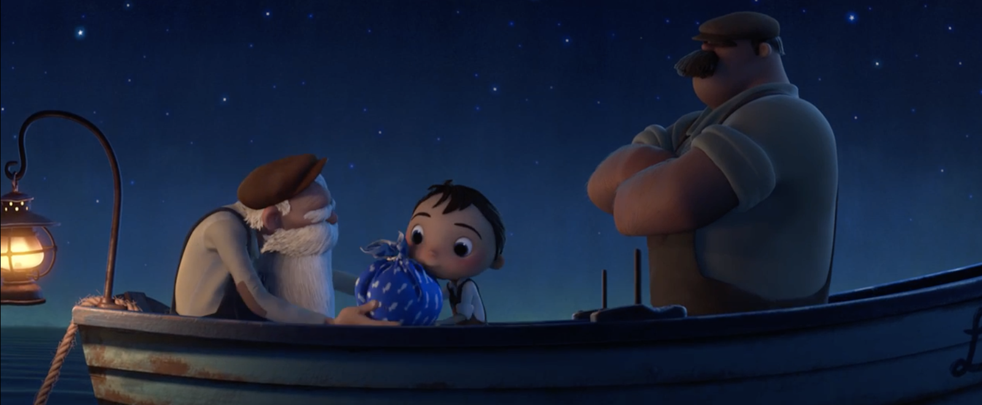
Your two sentences here:

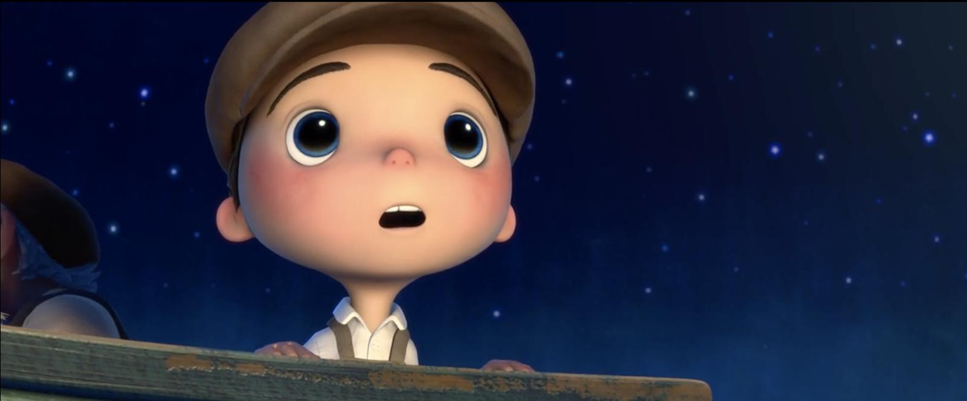

Your two sentences here:

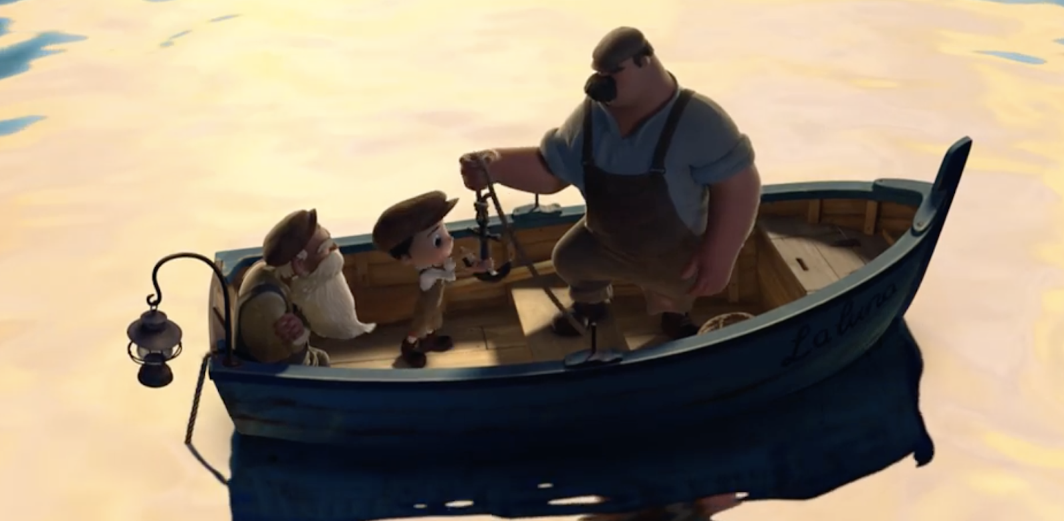

Your two sentences here:

