Monday Writing Task

Task One: After watching the La Luna trailer, fill in the grid answering these questions using full sentences:

Who do you predict the characters are? What do you think they are called? | Do you think the characters are related?
What happened in the clip? | What questions do you have?  What do you predict will happen next?

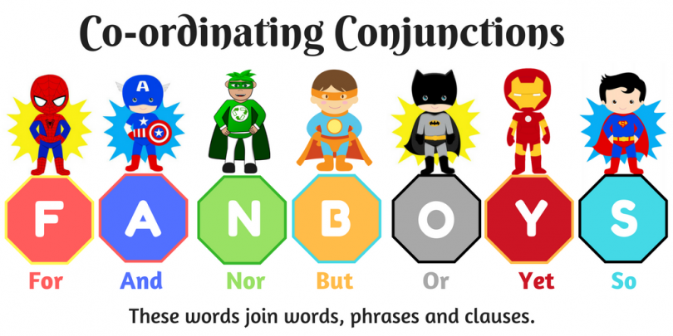
Task two: Summarise what happened in the trailer using three sentences. However, each sentence must include a certain grammatical feature:

- Sentence One: a coordinating conjunction
- Sentence Two: One fronted adverbial
- Sentence Three: use the present perfect form (instead of the past tense)

Sentence one:

Sentence two:

Sentence three:

