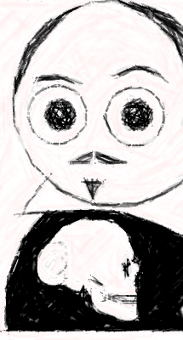
Hamlet – A Rap
By: Toby Price

Hamlet a prince,
Dad was the king,
Mum the Queen,
That’s how the story begins!

Hamlets best friend saw a ghost,
But it was Hamlet who wanted to see it the most!

Hamlet wanted to see his ghost dad,
Because not seeing him made him really sad!

His ghost Dad appeared, which is what Hamlet wanted to see,
“I was killed by your uncle – Please avenge me!”

Hamlet and his friends put on a play,
They want to hear what Claudius had to say!

King Claudius stormed out, stopping the play,
He wasn’t going watch any more – ‘No Way!

Hamlet wanted to kill the new king,
He had a chance,
But the new king was praying!

Hamlet wanted Claudius to go to hell,
So killing him right now wouldn’t go down well.

Hamlet went to visit his dad,
But the kings guards hurt him really bad!

Hamlet and the king started to fight,
They both fought with all of their might.

Hamlet was strong and made the king drink,
A goblet of poisoned wine,
He knew he had killed him this was the time!

Claudius was dead!
But the prince died too,
He was injured so badly there was nothing he could do!

